
Auckland University of Technology

ENSE707 – Software Quality
Assurance
GitHub Link: https://github.com/laksrahaha/Hospital-Management-System---Software-Quality-Assurance-
Assessment 2
Final Project Report

Group:
Hita Viswanathan - 23199037
Sravani Kunapuli - 23198431

Table of Contents
Introduction - hita 3
Task 1: Project Completion and Final Implementation - shared 3
1.1 Final System and the implemented features-shared 3
1.2 Chnages applied since mid scope project-shared 4
Task 2: Requirements Verification and Traceability-hita 4
2.1 Final Requirements & acceptance cirtieria-hita 4
2.2 requiremtns verification and tracealbity – hita 4
Task 3: Test Execution and Final Test Results -Shared 4
3.1 Final Manual and System Test Cases -Shared 4
3.2 Automated Test Suite and Results -Shared 5
3.3 Test Execution Summary -Shared 5
Task 4: Test Automation and Quality Engineering -Sravani 6
4.1 Automation Approach and Implementation -Sravani 6
4.2 Automated Test Results and Evaluation -Sravani 7
Task 5: Continuous Integration and DevOps QA -Sravani 7
5.2 Quality Gates, CI Results and Evaluation -Sravani 8
Task 6: Defect Management and Root Cause Analysis -Hita 9
6.1 Defect Management Process and Final Defect Register -Hita 9
6.2 Root Cause Analysis of Significant Defects -Hita 9
Task 7: Quality Testing -Shared 9
7.1 Quality Testing Approach and Risk-Based Selection -Shared 9
7.2 Quality Testing Results and Evaluation -Shared 9
Task 8: Quality Metrics and Final Release Decision -Sravani 9
8.1 Final Quality Metrics -Sravani 9
8.2 Final Quality Evaluation and Residual Risks -Sravani 9
8.3 Final Release Decision -Sravani 9
Task 9: AI-Assisted Development and Critical Reflection -Shared 9
9.1 GitHub Copilot Use and Evidence -Shared 9
9.2 Human Review, Modification and Testing -Shared 10
Task 10: Quality Improvement and Future Recommendations -Hita 10
10.1 Quality Lessons and Process Improvements - Hita 10
10.2 Future Quality Improvements Hita 10
Task 11: Team Contribution and Professional Reflection -Shared 10
11.1 Team Contribution Statement -Shared 10
11.2 Individual Professional Reflection -Shared 10
Conclusion - hita 10

Introduction – hita
ReserveHealth continues the hospital-management prototype from Assessment 1. It addresses accurate patient, laboratory and referral records and access appropriate to Doctors and Lab Technicians. The prototype uses demonstration data and is not connected to a real hospital.
This phase evaluates implementation through API automation, real-database browser checks, accessibility testing, defect investigation and CI. The evidence supports a controlled demonstration, with limitations preventing a production-readiness claim.

Task 1: Project Completion and Final Implementation - shared

Final System and the implemented features-shared
After the first project, ReserveHealth was extend so that we could address the limitation that were related to the security, patient-referral integration and referral monitoring, my contribution focused on these three features shown in the table above, with the aim of improving access control, data integrity, and the visibility of urgent referrals. For the first feature F01, the authentication was developed using ASP.NET Core password hashing and JSON Web Token JWT. After a successful login, a token would be generated that contained the staff's user identity and role. To enforce the Doctor and Lab Technician permissions we used backend authorisation, the we used the frontend uses the session information to manage the protected navigation, This provided the system with access restrictions at both levels instead of relying only on hiding interface elements.
For the second feature F02, patient and referral components were connected using patient identifiers. The workflow was before creating a referral the controller would check whether the selected patient exists and validates the required information. Any invalid links were rejected to prevent inconsistent records to make sure we had good test plans. We also implemented patient archiving in the referral system, this was done by making records inactive instead of deleting them, so this would preserve their existing referral history.
For the third feature F03, the existing P1, P2, and P3 priority labels were extended by attaching waiting time calculation based on the priority hierarchy system. These were taken from the earlier stakeholder interview that was done in project 1. The calculation were also based on the referral creation date. The frontend displays the waiting days that have passed and if a referral of P1 status exceeds the 14 day threshold it flags it as overdue. While the P2 and P3 referral levels display the waiting days without the automatic overdue thresholds. This improves the visibility of urgent cases while also identifying area for future development.

  - Table 1. Implemented capabilities and quality rationale
Area | Change described in report | Quality concern | Verification / boundary
F01 Authentication & RBAC | ASP.NET Core password hashing, JWT and backend role authorisation; frontend protected navigation. | Security / access control | Auth + RBAC automated tests, SEC01–SEC07; token expiry/revocation not covered.
F02 Patient–referral integration | Referral creation checks patient identifiers; archive preserves patient/referral history. | Data integrity / traceability | Five patient-referral integration executions in final TRX; SQL Server-specific persistence requires separate checks.
F03 Waiting-time visibility | Waiting days from referral creation date; P1 overdue at >14 days; P2/P3 days shown. | Timeliness / workflow visibility | Implemented feature stated in report; dedicated P1 boundary and P2/P3 test evidence not supplied in ZIP.
FR14 Laboratory requests | Clinician/lab request and result operations. | Functional suitability / attribution | Existing HT-L01–HT-L08 evidence cited by team report; full original criteria not verified.
FR15 Status/history | Referral transitions and historical event behaviour. | Traceability / integrity | HT-S01–HT-S07/TC08 referenced in report; priority-only history gap remains.
FR16 Audit | Audit service and view with role access restrictions. | Accountability / security | Selected audit and denial tests; comprehensive immutability not demonstrated.

Chnages applied since mid scope project-shared

In comparisons to the first project the first three features were improved so that the quality risks were addressed, as opposed to just adding functionality to the existing system. The role-based access improved the security, patient referral validation strengthened the data integrity, and the waiting time alerts improved the overall visibility of urgent referrals. These changes connect to the ISO/IEC quality attributes that were discussed in earlier lectures. The features are also good testable behaviours that can be later verified through testing.

  - Table 2. Assessment 1 limitation to Assessment 2 response

Earlier improvement theme | Response in this phase | Observable evidence / remaining work
Role/access restrictions | F01 backend JWT/role controls and tested API restrictions. | 9 automated RBAC tests, 7 manual security checks; session token revocation still unverified.
Patient-referral data consistency | F02 patient existence validation and non-destructive archiving. | Integration cases in the 21-test TRX; verify behaviour with actual SQL Server.
Urgent referral visibility | F03 waiting-day display, P1 overdue flag. | Feature described; add threshold/boundary test record where available.
Quantified quality evidence | Automation/CI results, security observations, Lighthouse audits. | 21/21 local suite; PR #28 successful CI; login 90→100 and Patient 95→100 reported.
Controlled release decisions | Residual-risk analysis and conditional demonstration recommendation. | Task 8; not a clinical production-readiness claim.

Task 2: Requirements Verification and Traceability-hita

2.1 Final Requirements & acceptance cirtieria-hita
Acceptance checks covered valid and blank laboratory information, duplicate entry, persisted edits, patient association, referral transitions/reasons/history and audit access. Verification requires observed outcomes rather than code alone.
Functional evidence shows specific operations; quality attributes also require appropriate security and interaction checks. A passing scenario does not establish complete requirement satisfaction.

2.2 requiremtns verification and tracealbity – hita
The provisional mapping below uses requirement areas identified in the handoff. Partially Verified means supporting evidence exists but complete approved criteria remain unchecked. Unverified and Out of Scope require explicit evidence or an agreed scope decision.
  - Table 3. Requirements/evidence verification matrix
Requirement / area | Primary test or source | Current evidence-backed status | Remaining verification
F01 / NFR04 access control | 21-test suite; SEC01–SEC07 | Selected access paths passed | Token expiry, invalidated JWT after logout, all protected routes.
F02 data links and archive | TRX integration scenarios; API validation | Selected cases passed | Actual SQL Server persistence, concurrency and broader history checks.
F03 referral age alerts | Feature narrative in Task 1 | Implementation reported; evidence not supplied | P1 day 14/15 boundary and P2/P3 behaviour test results.
FR14 lab requests | HT-L01–HT-L08; Lab requests controller | Partially verified (report) | Full approved acceptance criteria, unchanged/missing-ID paths.
FR15 status/history | HT-S01–HT-S07; report TC08 | Partially verified (report) | Priority-only history and wider transitions.
FR16 audit access | Audit service; HT-A01/A03; audit API checks | Partially verified (report) | Immutability, attribution and tamper-resistance.
Accessibility area | Patient QT-A02–05; login Lighthouse | Selected checks passed | Screen readers, dialogs, zoom, responsive, full WCAG criteria.

Task 3: Test Execution and Final Test Results -Shared

3.1 Final Manual and System Test Cases -Shared

After the changes were made to the patient and referral workflow we had to verify that the patient information could still be retrieved correctly as opposed to just assuming the updated system was reliable. Tests TC01-TC04 were linked to requirements FR01-FR04. The first two test cases focused in retrieving the patient information making sure that it worked as intended, while TC03 introduced a negative scenario using an invalid patient ID. TC04 extended our testing to the dashboard and we checked whether the required information was still being displayed correctly. We tried to implement functional, negative and system testing approaches so we could identify as many failures as possible and provide evidence of reliability and usability.

3.2 Automated Test Suite and Results -Shared
In regards to automated testing we tested whether the changes to authentication, role-based access and referral functionality affected the existing system. Initially we developed tests that covered authentication, role restrictions and referral validation. We included scenarios with invalid credentials, unauthorised access and incorrect referral information. However while we were executing these tests we found that there were problems in the testing environment. The test configuration was still attempting to use the SQL Server LocalDB alongside the in-memory database, which prevented some tests from running correctly. To address this we modified the test factory configuration so that the SQL Server registration was removed and replaced with the isolated in-memory database. We also had to provide the missing JWT configuration for the testing environment.
Another problem we faced was when testing the login with an invalid password. The initial test happened on an account that did not exist anymore so it could not be properly tested in the password verification process. We corrected this by creating a valid user before we attempted to login with an incorrect password. After we made these changes we re-executed the tests and all of the tests passed and we reached 16 passing results.
Then we expanded the automation with the patient-referral integration scenarios. These helped us to check whether the referrals were matched to the right patient, whether the archive history was saved for each patient and whether an invalid patient was rejected. After the second set of features were tested the final test cases were brought to 21 tests all of which passed in both the test environment and the test scenarios. This ensured that we were able to verify the tests properly instead of only checking for the final functionality of the features.
  - Table 4. Negative and boundary-focused API evidence map
ZIP test ID | Observed test intent | Recorded outcome | Source screenshot
TC10 | Missing patient on referral creation | 400 / Pass | TC10_CreateReferral_MissingPatient...
TC11 | Blank referral reason | 400 / Pass | TC11_CreateReferral_BlankReason...
TC12 | Invalid priority P4 | 400 / Pass | TC12_CreateReferral_InvalidPriority...
TC13 | Invalid referral status transition | 400 / Pass | TC13_UpdateReferral_InvalidStatusTransition...
TC14 | Login invalid email | 401 / Pass | TC14_Login_InvalidEmail...
TC15 | Wrong password (initial fixture then corrected) | Initial failed run; retested 401 / Pass | TC15_...Failed and ...Passed
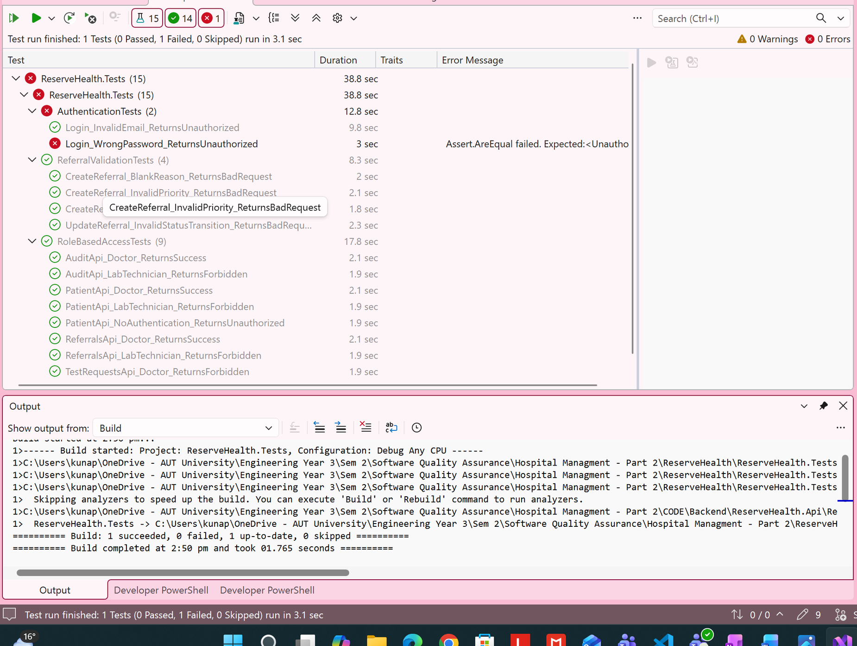
Figure 1. Earlier invalid-password test failure caused by an unsuitable test prerequisite.
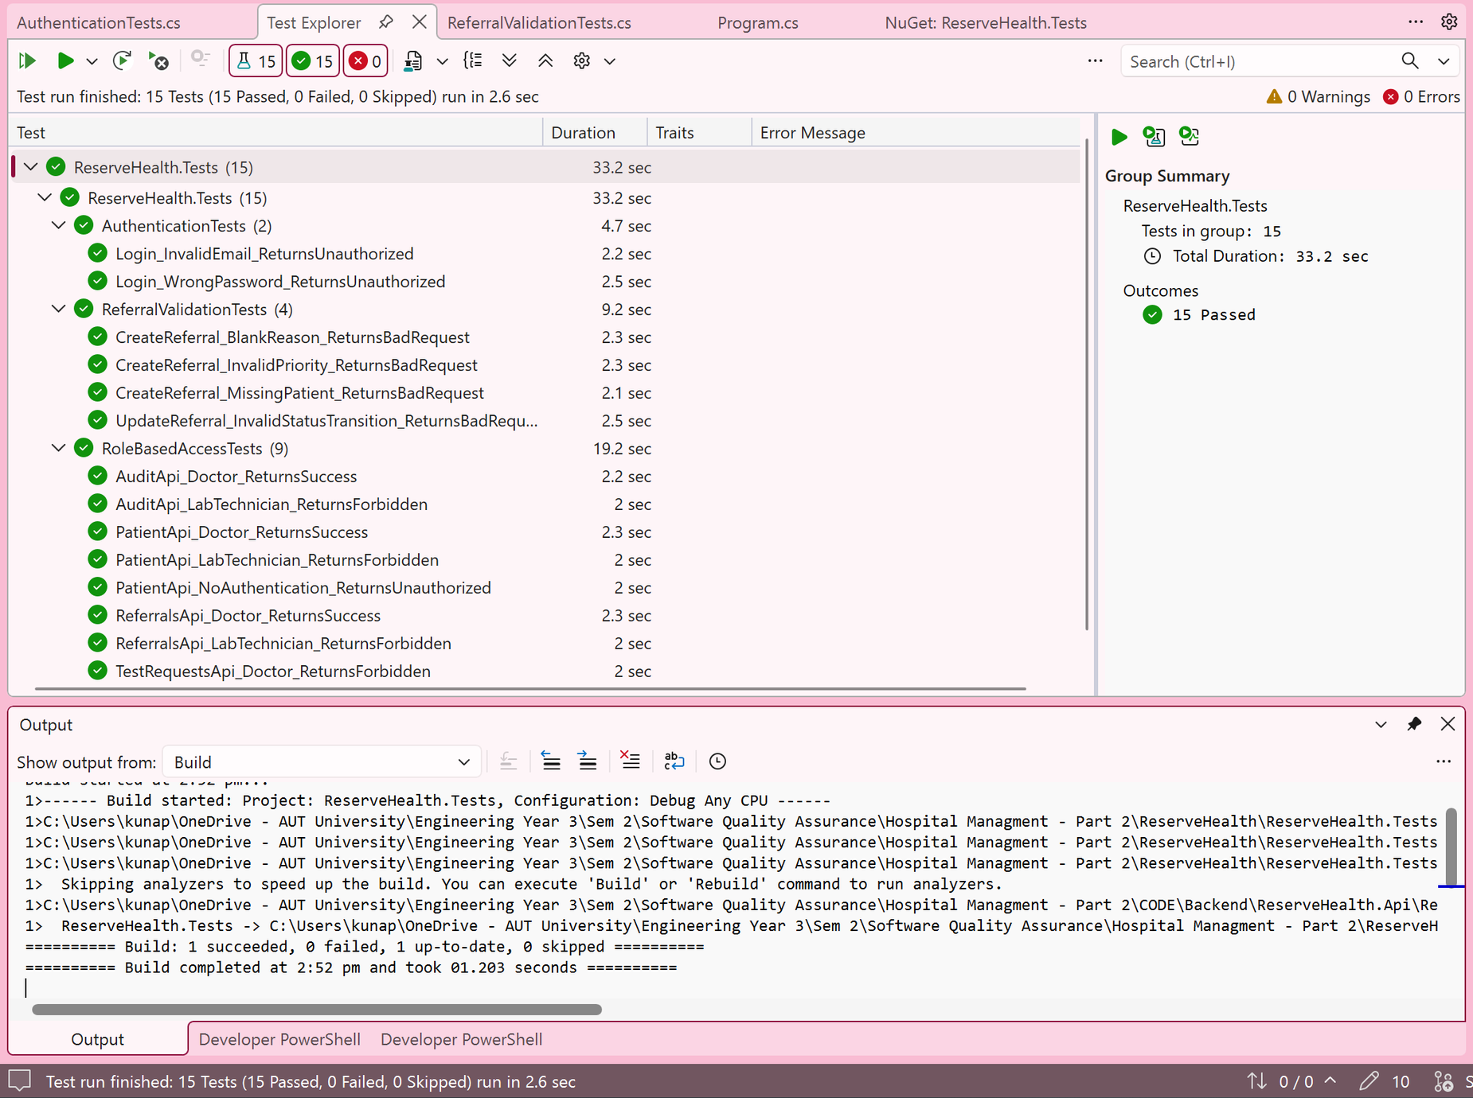
Figure 2. Corrected invalid-password test returning the expected 401 response.

3.3 Test Execution Summary -Shared
After we completed the automated and manual testing, the results were reviewed and evaluated based on the functionality of the final system. As shown in Table 7, the final automated execution recorded 21 tests, all of which passed with no failures. These results were achieved after the earlier failed executions and the corrections made during testing. We also included additional integration scenarios and continued testing the system after the changes were made to check that the existing functionality was still working as expected.
To ensure that the frontend maintained good usability and was connecting to the backend properly, I executed TC01–TC04 manually to verify the patient functionality from the user's perspective. During these tests, patient records could be retrieved, individual patient information was displayed correctly, and the dashboard continued to work after the updates. I also tested an invalid patient scenario to check whether the error handling was being carried out correctly through the interface.
One of the trade-offs we made during testing was using an isolated in-memory database instead of the actual SQL Server database. As mentioned in the previous section, this change was necessary to resolve problems with the automated testing environment and allow the tests to execute correctly. However, this also introduced a limitation, as the automated test results could not fully verify database-specific behaviour or every interaction through the frontend. The remaining manual testing results also needed to be completed and considered before we could determine whether the system was ready for release.
  - Table 5
lass | Executed | Passed | Failed | What the suite supports
Authentication | 3 | 3 | 0 | Invalid email; incorrect password; invalid signup role.
Role-based access | 9 | 9 | 0 | Patient, lab request, referral and audit API access decisions.
Referral validation | 4 | 4 | 0 | Missing patient, blank reason, invalid priority, invalid status transition.
Patient-referral integration | 5 | 5 | 0 | Valid link, archived history, 3 invalid patient IDs (data-driven).
TOTAL | 21 | 21 | 0 | 100% pass rate in the recorded TRX execution.

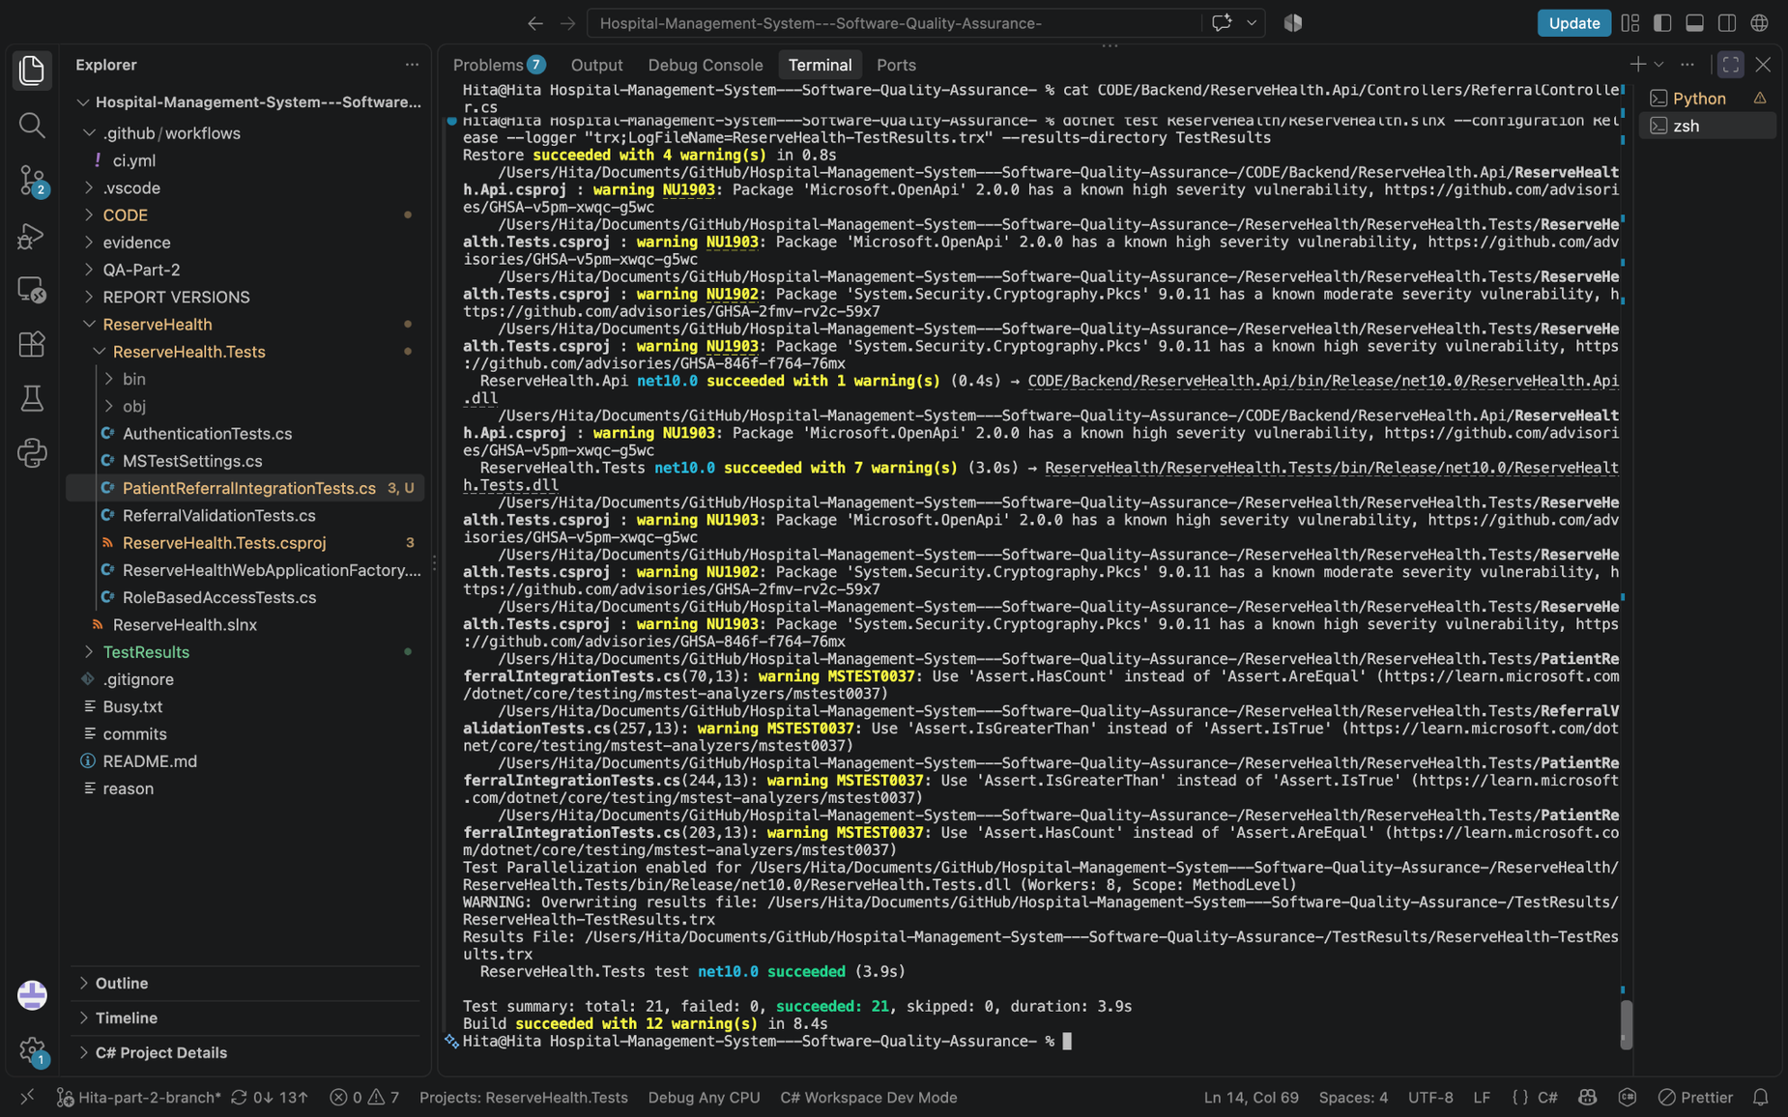
Figure 3. 21 passed tests

Task 4: Test Automation and Quality Engineering -Sravani

4.1 Automation Approach and Implementation -Sravani
After testing we were able to find the areas that need further testing. For this we used automated tests using MSTest within the .NET testing environment. To deal with the security and data integrity risk, which are a very crucial part of our system we focus our testing on authentication, role-based access control, referral validation and patient-referral integration. This made sure we could test the behaviours of the system after we changed the code instead of having to manually repeat each API test.
In regards to the API testing we used WebApplicationFactory to create a test instance of the ASP.NET Core application and send HTTP requests to the controllers. This allowed us to test the actual API behaviour. This meant we did not need to run the frontend for every test. We made use of MSTest assertions to compare the responses against the expected results, including the 401 Unauthorized, 403 Forbidden and 400 Bad Request messages. To test the access-based roles, we used test authentication to simulate Doctor and Lab Technician permissions, allowing us to check whether the controllers correctly enforced their access restrictions. We then used authentication tests separately examined login and signup validation.
As mentioned in before sections we encountered issues when the test environment attempted to use the SQL Server connection. To ensure that our tests were more reliable we used a local database setup and changed the configuration of the test so it could use an isolated Entity Framework Core in-memory database. This allowed for our test records to create and checked without having to depend on the main application database. This also showed us that database-specific behaviour still needed a required separate verification.
  - Table 6. Test-design decisions and limits
Choice | Why it was suitable | What it does NOT verify
MSTest assertions | Repeatable expected/actual status comparisons (401/403/400 and success). | End-to-end clinical use and usability.
WebApplicationFactory | Exercises hosted ASP.NET Core API/controller interactions. | Physical deployment and every external dependency.
Simulated staff identities | Isolates Doctor/Lab Technician authorisation branches. | Full real login and token lifecycle for all RBAC cases.
EF Core InMemory | Isolates test data and enables repeatable runs/CI. | SQL Server constraints, transactions and migrations.
Browser/manual checks | Covers actual navigation/session states for selected scenarios. | Comprehensive penetration, accessibility or production testing.

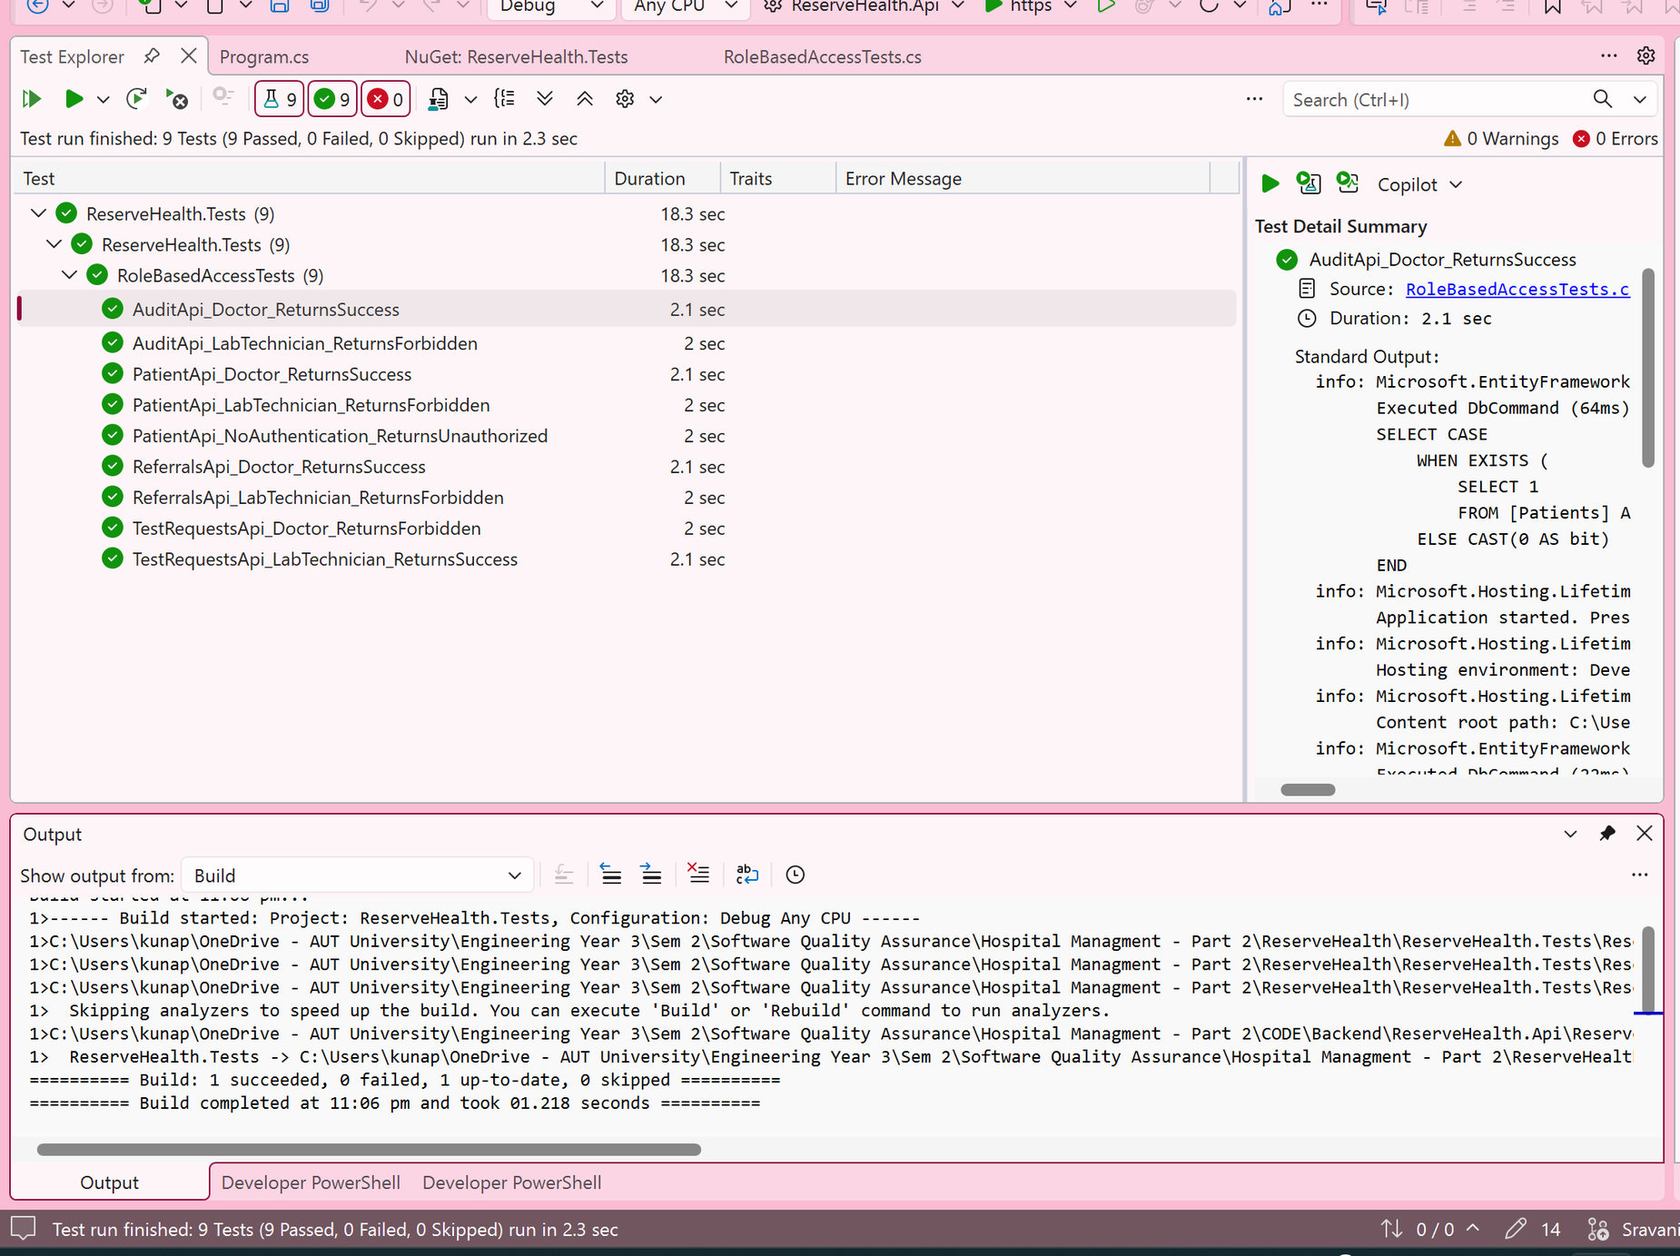
Figure 4. Successful local execution of the nine role-based access tests.

4.2 Automated Test Results and Evaluation -Sravani
Once the earlier testing issues were resolved, the final automated tests recorded were 21 passed tests with no failures. This was an improvement from the initial execution, where problems with the test environment and test scenarios prevented the tests from running successfully. After we corrected these issues we were able to execute the same tests repeatedly and check whether the changes to the system had affected the previous working functionality. This was very useful for authentication and role-based access, where an incorrect change could allow users to access the functions that were outside of their assigned roles and its corresponding permissions.
Despite having benefits to automated testing where we could test multiple scenarios without manually repeating each request through the frontend we still found that automated testing required maintenance. After we applied changes to the API, the authentication configuration or database setup could affect the tests, even if the system functionality itself was not correct. This became very apparent when we had to modify the test factory file and the authentication test setup to achieve reliable execution results.
Despite the system passing all 21 tests, the results did not confirm that every part of the system was functioning correctly. The in-memory database did not reproduce all SQL Server behaviour, while the simulated authentication used for role-based tests did not verify the complete real-login process. Therefore, manual testing and testing against the actual database were still important for evaluating the system beyond the automated scenarios.

Task 5: Continuous Integration and DevOps QA -Sravani
After the automated testing the next aspect we needed to account for was whether the changes made to the repository would continue to build and pass the tests when integrated with the rest of the project. We had to make sure what we were building and integrating actually made sense for the project. For this we introduced a continuous integration workflow using GitHub Actions. We designed a workflow that would run during pull requests and pushes to the GitHub repo. It checked out the project, set up the .NET environment, restored dependencies, built the solution and executed the automated tests. Test results were also saved as an artifact so we could review them once the execution was completed.

To make the CI pipeline work without any errors took us a lot of effort. The initial four or five workflow executions failed. One of the first problems we encountered was the solution path trying to locate and build the project. After we corrected that we continued encountering problems with the automated tests since they were originally dependent on SQL Server LocalDB, which was available on our local system but not in the CI environment. This meant that we could run the automated tests locally but not through CI. As mentioned in the above paragraph this is why we had to keep changing the SQL Server LocalDB configuration to ensure it did not cause problems for other aspects of our test plan.

We then continued to make changes to the testing configuration, including isolating the database dependency and then correcting the authentication test setup. After several changes and execution runs on GitHub Actions we finally were able to get successful completions of the workflow. During this process we realised that running tests locally was not enough to confirm that the project could be built or tested independently in other environments, it lacked reproducibility. So we had to correct that.

Following these corrections, the CI workflow successfully completed the build and automated testing stages. The results were also uploaded as a test artifact, providing a record of the execution. This made it possible to identify integration problems through the repository workflow rather than relying entirely on manual testing before combining changes.

  - Table 7. CI/test-environment issue-to-resolution history
Stage | Observed issue or activity | Correction / outcome | Evidence
Early local run | Three authentication tests failed under test setup. | Test factory/JWT configuration and fixtures reviewed. | Task5_InMemory_Authentication_3Tests_Failed.png
Authentication rerun | Three authentication tests successfully executed. | 3/3 passed. | Task5_InMemory_Authentication_3Tests_Passed.png
Expanded local suite | Role, validation and login checks runnable in isolated setup. | 16/16 passed. | Task5_CI_All16Tests_Passed_After_Action.png (screenshot is Test Explorer, not CI log).
GitHub Actions evidence | Workflow produced downloadable test results. | Artifact visible in Actions. | Task5_CI_TestResults_Artifact.png
Updated PR integration | PR #28 build-and-test check green for new patient-referral changes. | Recorded successful PR workflow. | Hita-PR28-CI-Passed.png
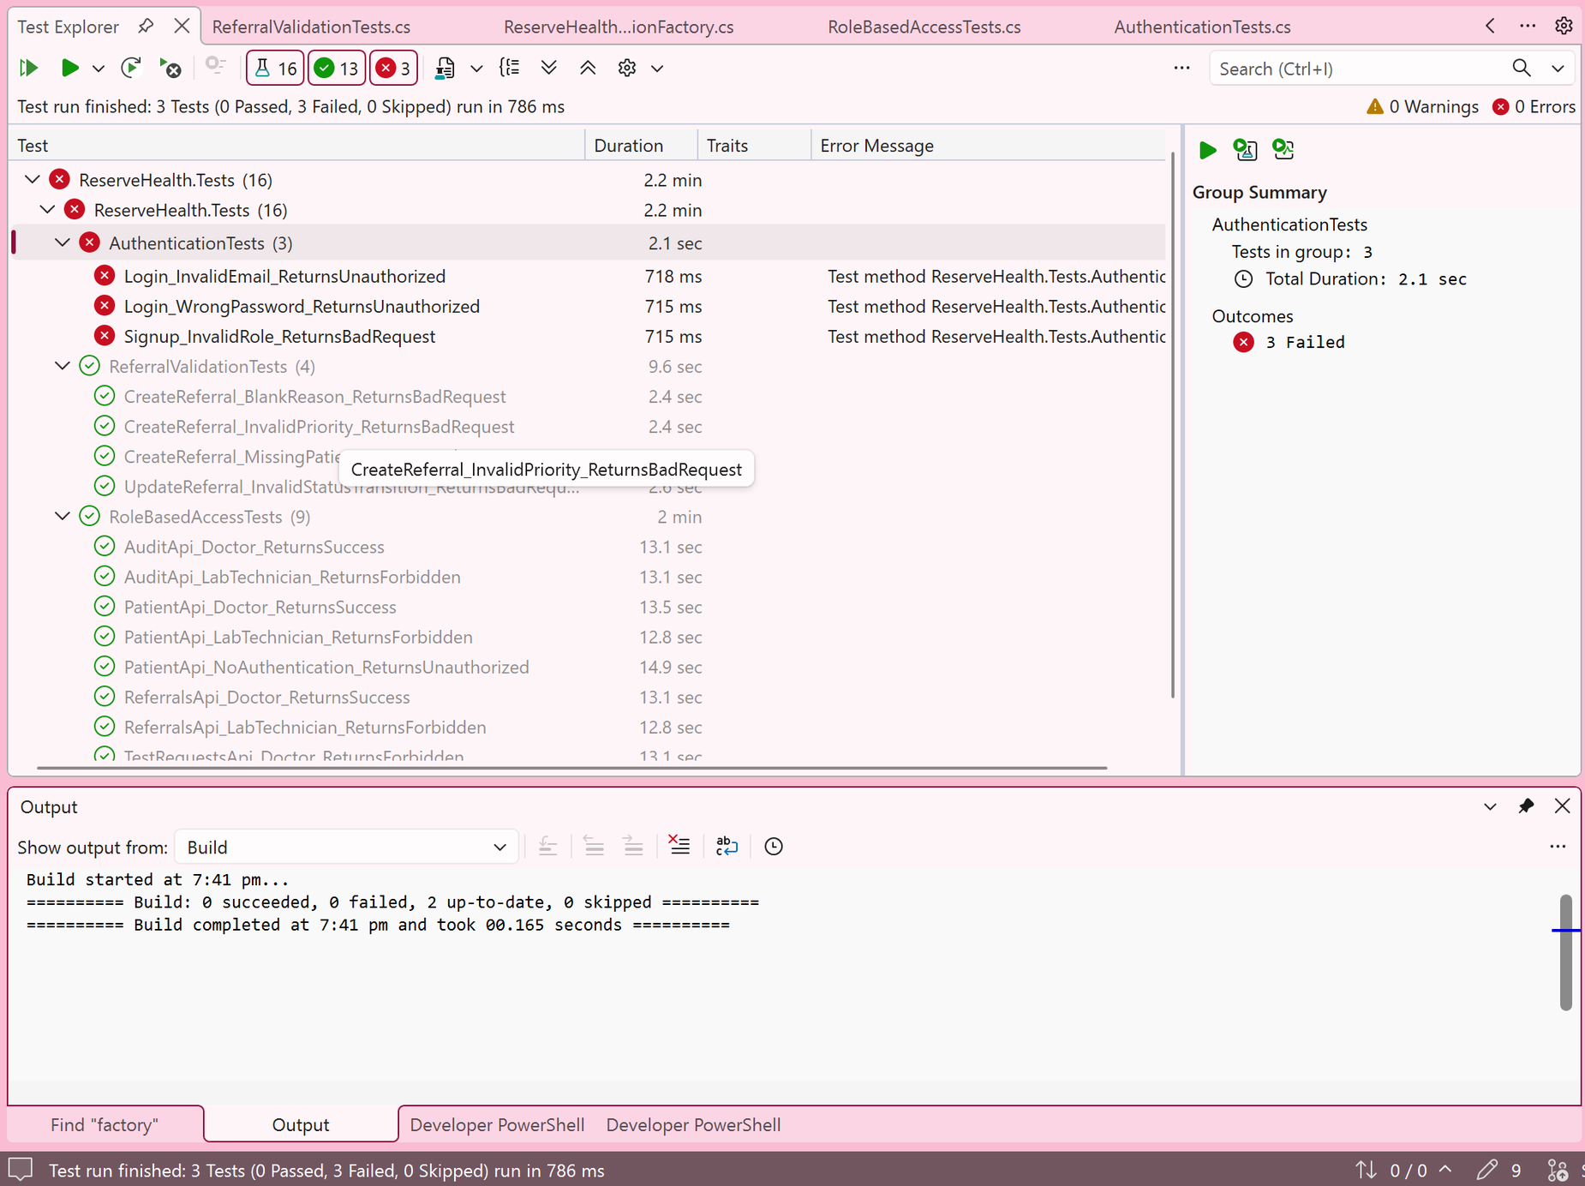
Figure 5. Authentication-related test failures during early test-environment configuration.
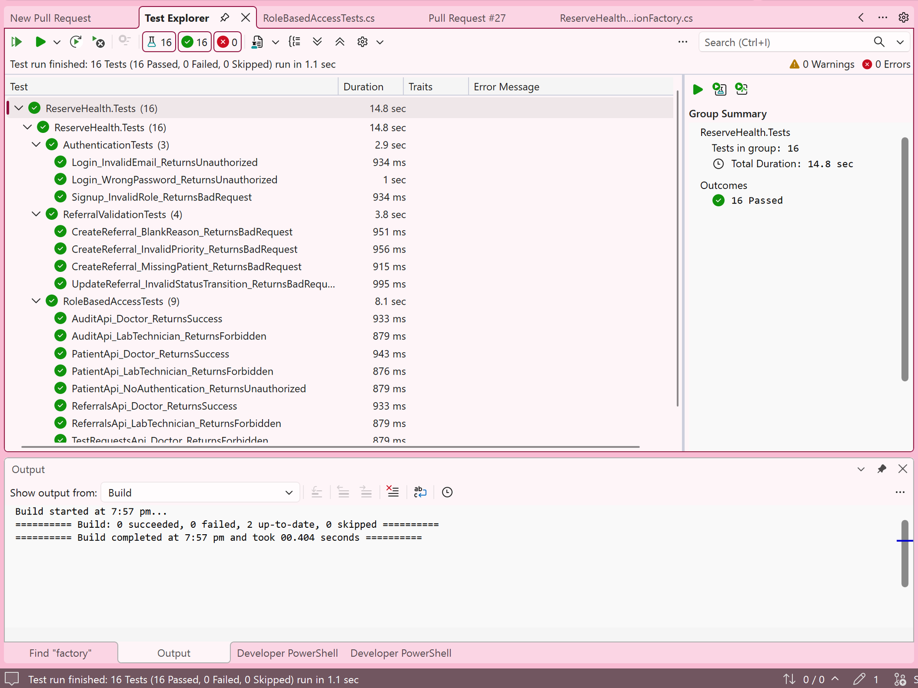
Figure 6. Subsequent local execution showing 16 passing automated tests.

5.2 Quality Gates, CI Results and Evaluation -Sravani

After we managed to correct and execute a successful CI workflow, we were able to use the build and automated testing stages as quality checks for the changes that were made in the repository. The workflow checked whether the dependencies could be restored, the solution could build successfully and automated tests could execute without failures. This was crucial because previous attempts showed a lot of workflow failures. We realised that successful local testing environments did not necessarily mean the same code would work in another environment. By adding these checks in GitHub Actions, we were able to identify the integration problems before considering the changes ready for merging.
The successful GitHub Actions execution provided evidence that the build and testing stages were functioning correctly. The results were also uploaded as an artifact, allowing us to review the testing evidence instead of relying only on the successful workflow status. We also had a final recorded local execution of 21 passing automated tests. However, we recognised that passing tests alone did not guarantee the overall quality of our system especially when the tests executed were limited to specific scenarios.
Although the CI workflow was successful, some warnings were still recorded, meaning further review was needed. Another limitation was that a successful workflow did not automatically prove that merging was restricted by a required status check. Thus, the CI process improved the consistency of our testing, but stronger quality gates and additional checks would be needed to be done to support a more reliable release process.
Gate / control | Observed evidence | Judgement / follow-up
Restore and build | Green build-and-test workflow on PR #28. | Supports reproducibility of this revision; earlier environment problems resolved in tested context.
Automated test execution | TRX 21/21 local; PR #28 CI check green. | Do not assert 21/21 on CI solely from green PR check; locate CI TRX to verify its test count.
Result retention | Actions artifact shown in ZIP. | Evidence is available for audit/download.
Protected main branch | Report claims both “not proven” and “enforced.” | Check actual branch rule, required status-check name and blocked direct push before asserting enforcement.
Dependency/security warnings | Report records unresolved OpenAPI/Pkcs advisories and build warnings. | Review/triage before any broader deployment.
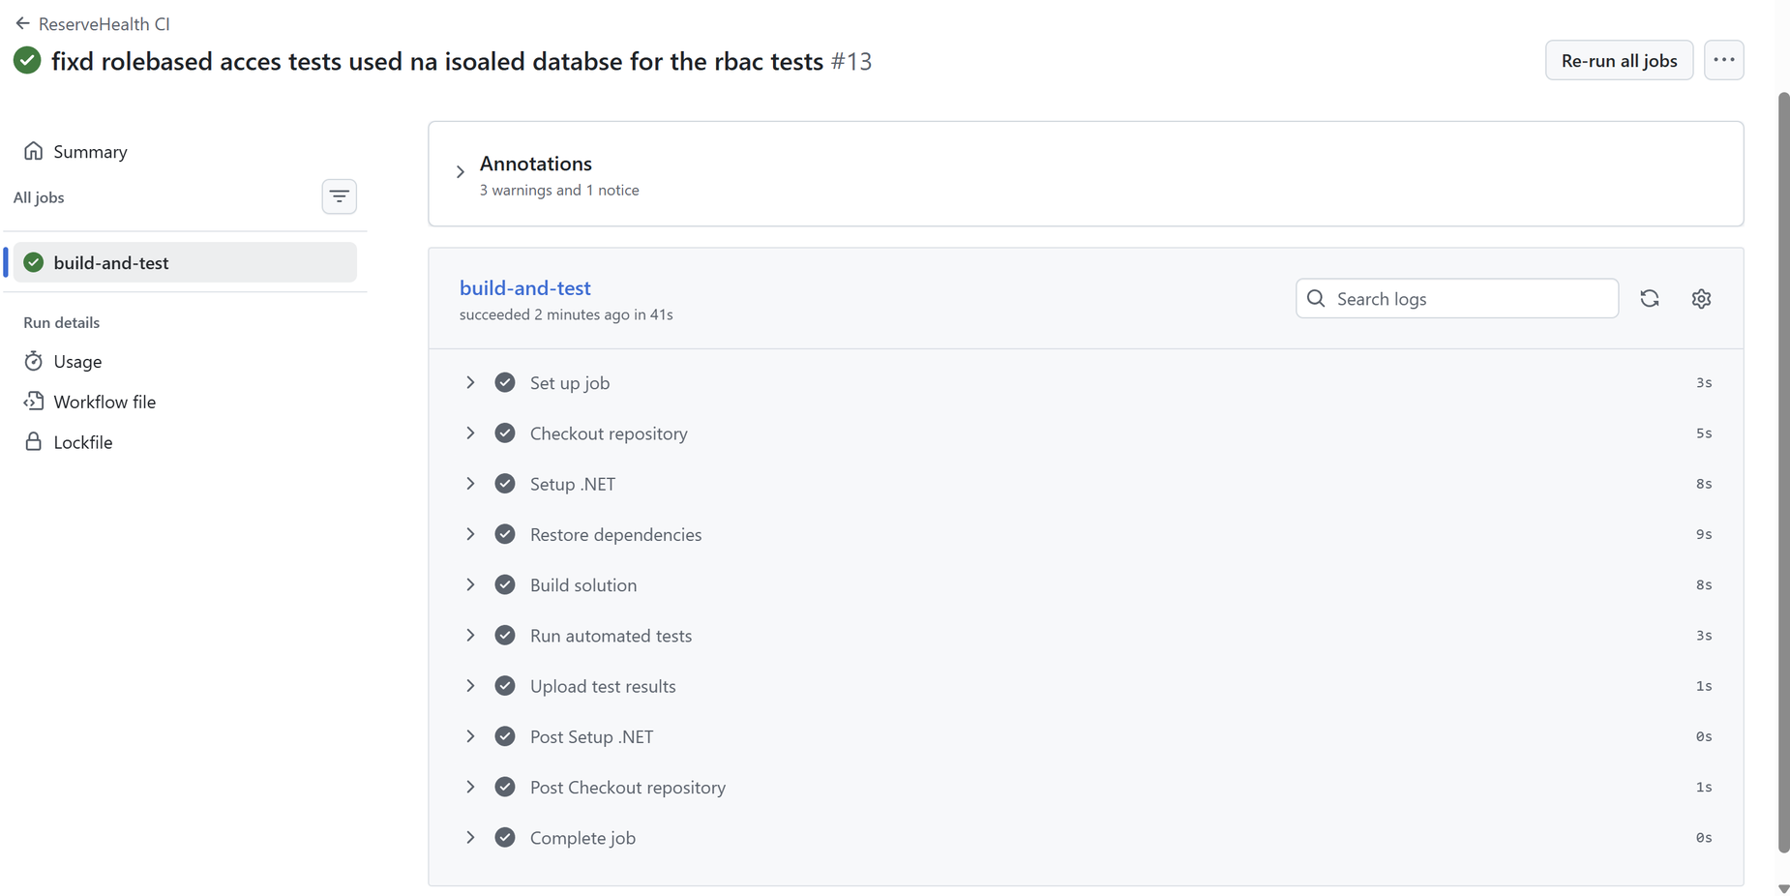
Figure 7. Test-results artifact produced by the GitHub Actions workflow.
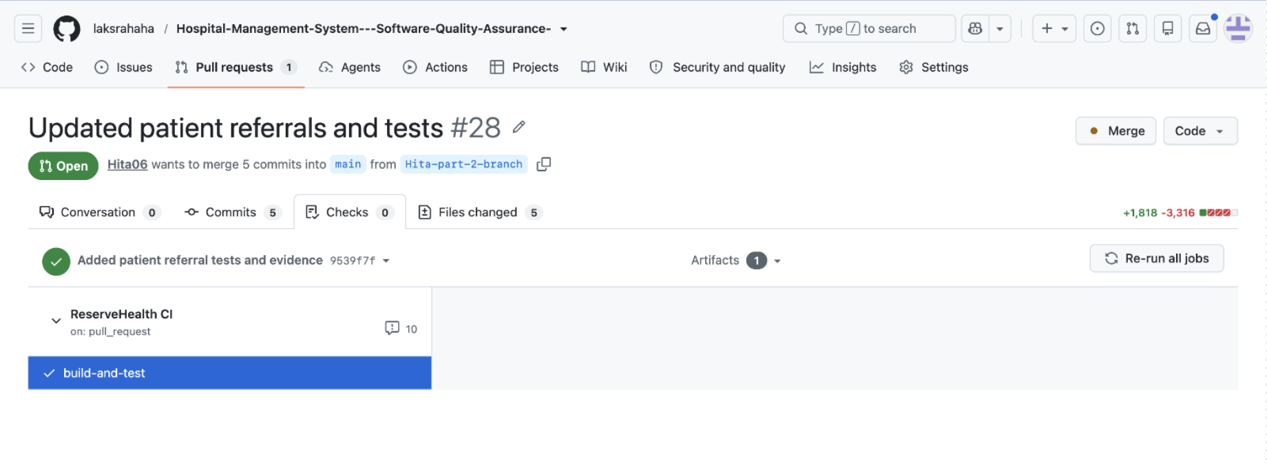
Figure 8. Successful build-and-test check reported for pull request #28.

Task 6: Defect Management and Root Cause Analysis -Hita

6.1 Defect Management Process and Final Defect Register -Hita
Severity describes impact: Critical indicates fundamental loss of protection/service; High blocks an essential workflow; Medium significantly restricts use with a workaround; Low is minor. Priorities P1/P2/P3 indicate urgency and are distinct from referral urgency. Register classifications below are provisional.
The reporting lifecycle is New, Investigating, Fixed, Retest and Closed, allowing Reopened or Deferred. Closing requires an observed retest, not merely a code change. Historical intermediate dates are not invented. The register is an evidence-backed subset of team findings.
  - Table 8:
ID and type | Finding and classification | Fix and evidence | Status
D01 Runtime setup | Database unavailable at sample-data startup; High / P1 | Development migration before seeding; e32866e; Task6 before/fix/after | Closed in tested Windows setup
D02 Accessibility | Patient contrast finding; Medium / P2 | Shared CSS colours corrected; 4ce8cd5; Lighthouse 95 to 100 | Closed for audited state
D03 Test prerequisite | No Outstanding lab request; Medium / P2 test blocker | Controlled sample request; 40d365b; saved-result retest | Resolved prerequisite; not a failed lab algorithm
D04 Test configuration | SQL Server provider/JWT test setup; High / P1 for automation | Partner report describes factory/config changes and passing suite | Reported resolved; original fix reference to confirm
D05 Test design | Wrong-password check used missing user; Medium / P2 | Partner report describes valid-user fixture and rerun | Reported resolved; fixture diff to confirm
R01 Dependency risk | OpenApi and Pkcs vulnerability warnings; P1 review before wider release | No dependency fix evidenced; build output retains warnings | Open risk; advisory severities high/moderate
Five issue records and one dependency-risk group are listed. D01/D02 have direct correction evidence; D03 is a resolved prerequisite; D04/D05 need original references. Mixed categories do not support a final closure percentage. Repeated warning lines are not separate defects.

6.2 Root Cause Analysis of Significant Defects -Hita
D01 Database startup failure:
On the university computer, startup failed while seeding attempted to read Patients, before browser testing could begin. The issue concerned database readiness. Development startup was corrected to apply Entity Framework migrations before SeedData.AddSamplePatients, and the rerun successfully started the API.
Hita’s Program.cs correction is e32866e. Before/fix/after evidence is retained below. Prevention requires clean-machine setup instructions, migration checks and an empty-database smoke test. Production migration permissions, backup and rollback require a separate deployment process.
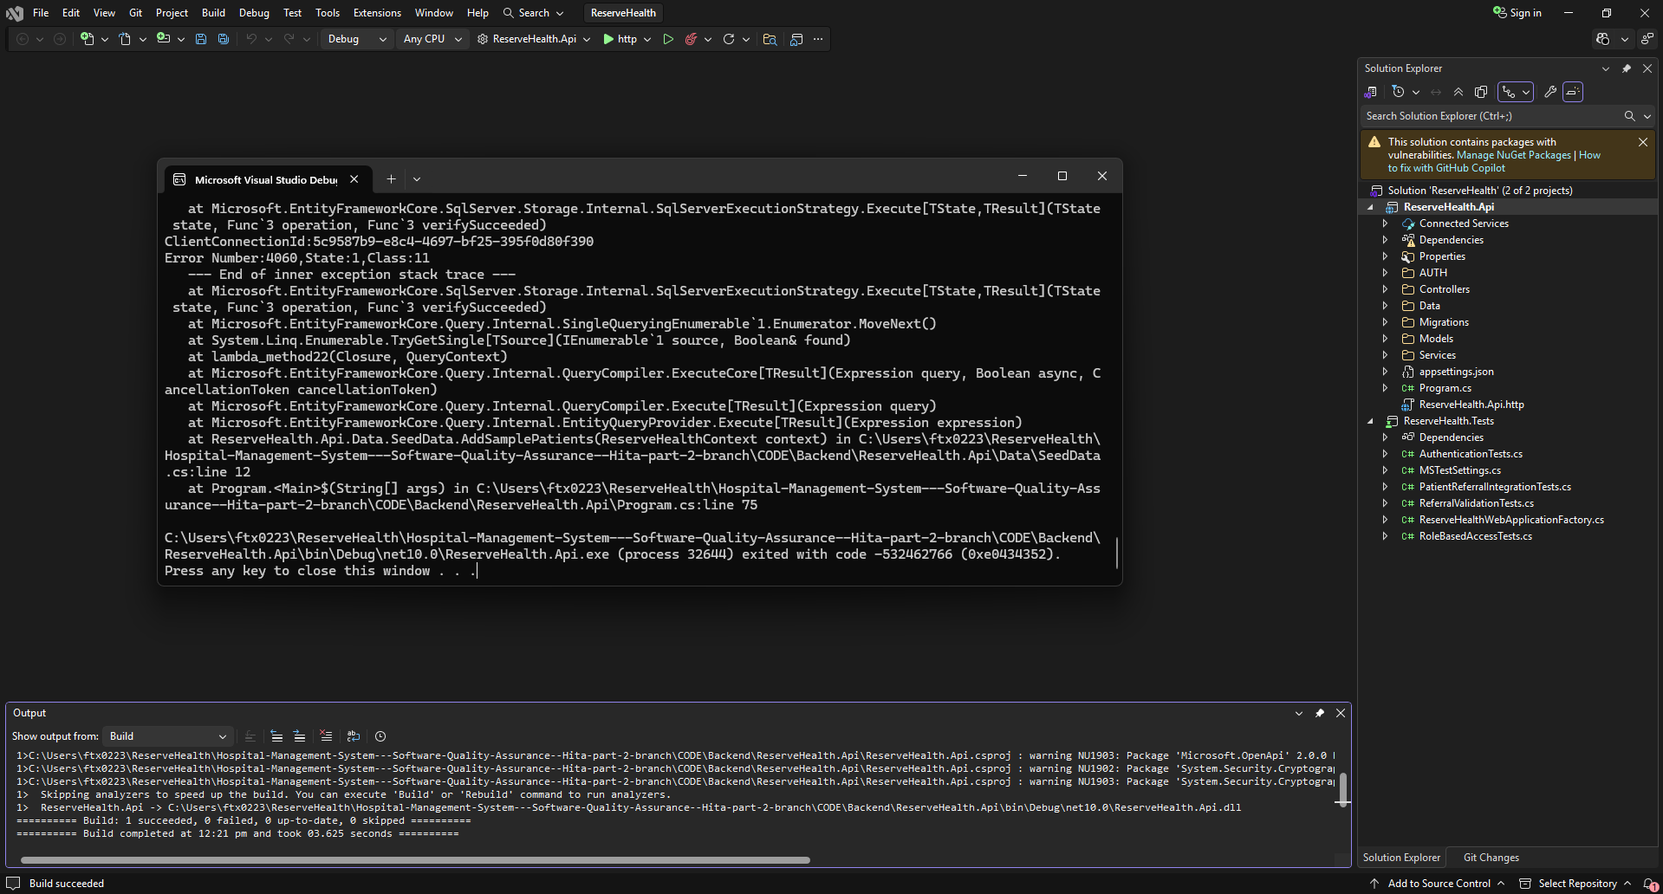Figure 9. D01 original startup failure before the development migration correction.

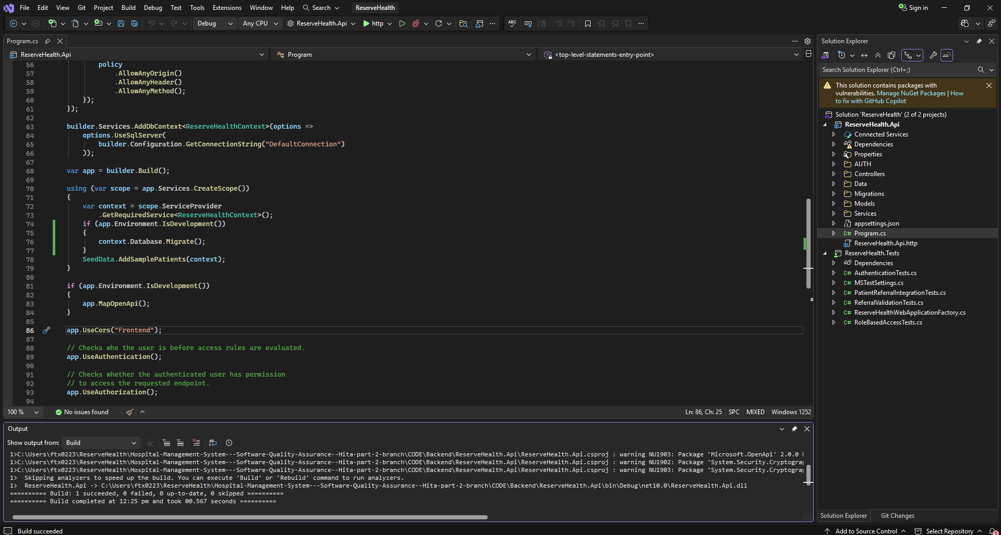Figure 10. D01 development migration change before sample-data seeding. Fix commit e32866e.
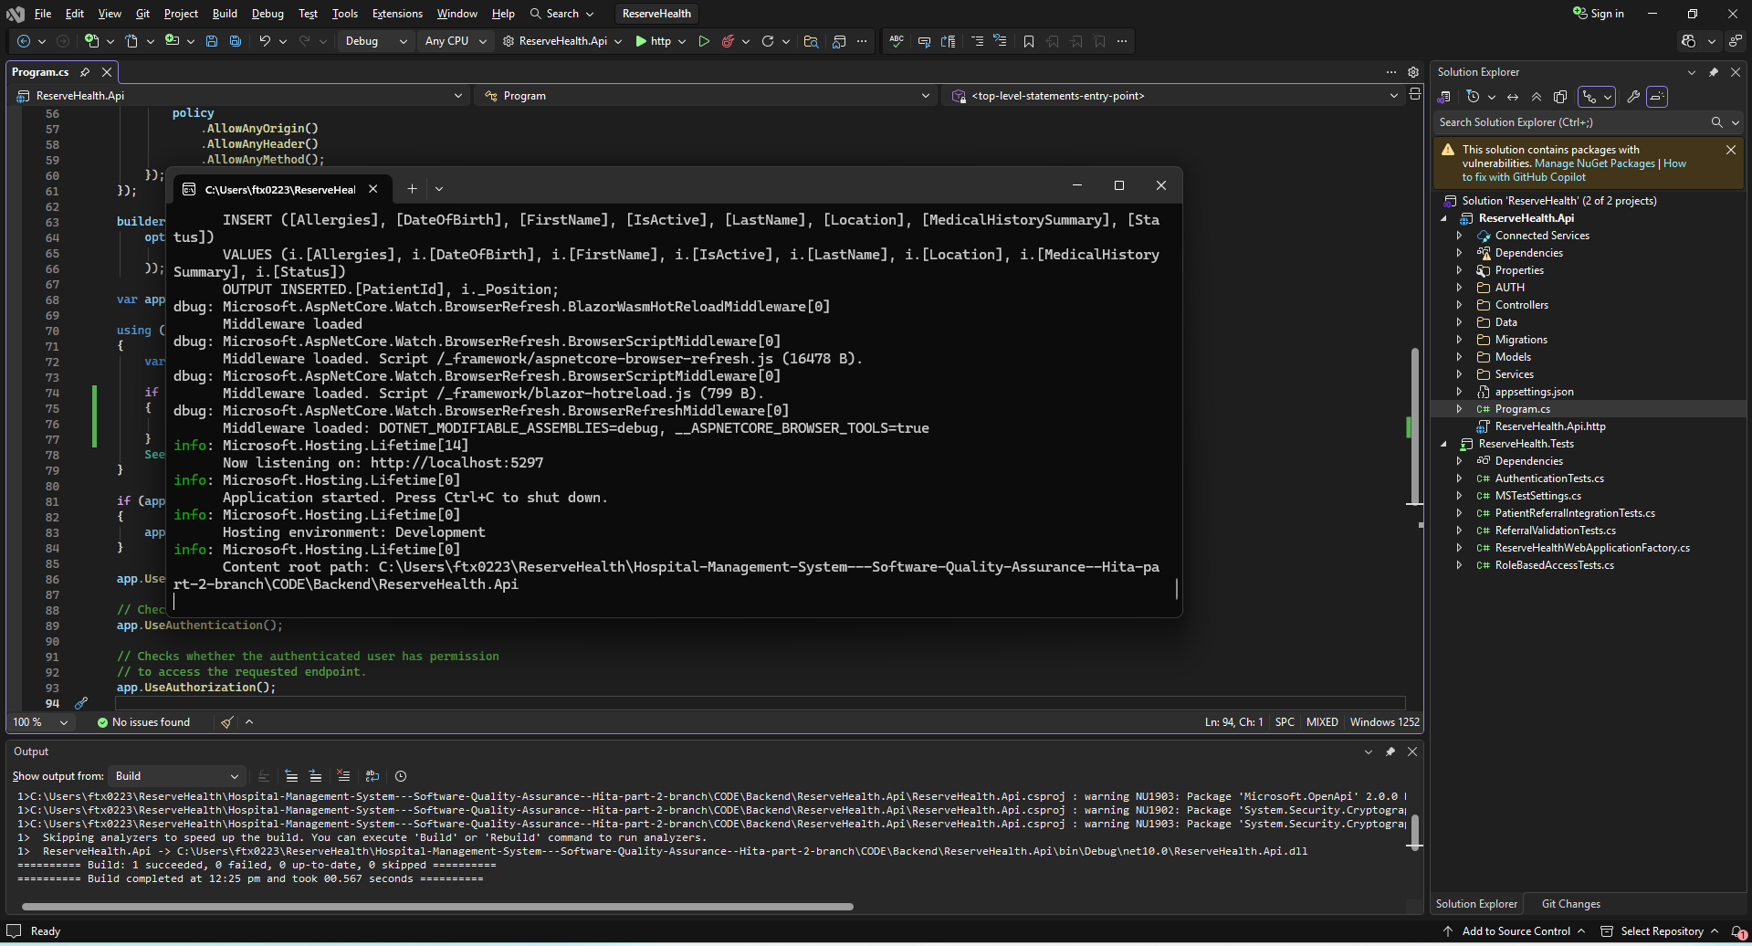Figure 11. D01 successful startup retest. Evidence is limited to the tested local development environment.
D02 Patient page contrast finding:
Lighthouse scored the functional Patient page at 95 with insufficient contrast. Shared CSS changed blue #3d8ead to #236580 and muted text #6e7c86 to #52616b. Commit 4ce8cd5 was followed by a repeated audit scoring 100.
The cause was the shared colour choice, not a failed data operation. Prevention requires contrast checks and regression checks across affected pages and states. A successful single audit does not establish complete accessibility.
D04 Automated test environment configuration:
The partner’s investigation describes SQL Server LocalDB conflicting with the in-memory provider and missing JWT test settings. Application dependencies were not fully replaced for the test host. The stated correction removed SQL Server registration, supplied test configuration and isolated test data. Later executions reached 16 and then 21 passing cases.
This is a test-environment defect rather than proof of faulty business logic. Explicit factory dependencies and Linux CI reduce recurrence. Original failure logs, the configuration diff and fix attribution are still needed: later passing tests alone do not prove the earlier cause.

  - Table 9. Defect cause, evidence and prevention linkage
Issue | Most supportable cause | Evidence of action / status | Prevention and residual limit
D01 Startup | Database schema not ready before sample-data seeding. | Migration-before-seeding fix (commit e32866e); local startup retest. | Clean-machine migration and environment smoke test; production migration untested.
D02 Contrast | Shared foreground/background colour contrast. | CSS update (commit 4ce8cd5); Patient Lighthouse 95→100. | Automated contrast regression and broader keyboard/screen-reader coverage.
D03 Lab prerequisite | No Outstanding sample test request available for scenario. | Controlled sample request; prerequisite resolved. | Fixture setup and reset checklist; not evidence of a lab algorithm defect.
D04 Automation config | SQL Server/EF InMemory registration and JWT settings misaligned. | Factory config changes; subsequent 16→21 passing tests. | Preserve config diff, clean Linux CI run; SQL Server still needs checks.
D05 Wrong-password test | Invalid test fixture used a missing user. | Valid user created; corrected 401 result and pass screenshot. | Arrange valid account before negative-password check.
R01 Dependencies | Recorded third-party package vulnerability advisories. | Open risk, not a verified fix. | Review advisories, update dependencies and rerun CI before wider release.

Task 7: Quality Testing -Shared

7.1 Quality Testing Approach and Risk-Based Selection -Shared
We selected security and accessibility as the main two areas for quality testing. We chose them based on the risks that we found to correlate with how ReserveHealth would be used. We selected security because the system handles patient information while also providing different levels of access to Doctors and Lab Technicians. Despite all the users making use of the same program, the responsibilities and permissions vary between the users. This brings up a concern of unauthorised access if the restrictions cannot be enforced properly. One major concern was if the user could bypass the frontend restrictions and directly access the protected pages or send requests to the API. To combat this, we focused on authentication, role-based authorisation and session handling, using both the browser interactions and the direct API requests to investigate how the system would respond to different access attempts.
The second quality testing area was accessibility. This was selected because despite a feature being able to carry out its functionality, it does not mean that users can still interact with it effectively. Our system, ReserveHealth, has so many different functions that unclear forms or poor visual contrast could make these tasks harder to complete. Lighthouse auditing and manual interface checks were therefore selected to investigate issues that might not be apparent during ordinary use. The two quality areas were evaluated using different methods because the risks themselves were different: security testing focused on preventing inappropriate access, while accessibility testing examined whether the intended users could interact with the interface effectively.

7.2 Security and Role-Based Access Testing

7.2.1 Security Testing Methodology
To carry out the security testing we manual ran the ReserveHealth application and its actual backend API as opposed to only relying on the automated tests with simulated authentication. This helped us to observe and interact the role restrictions from the perspective of the users. We made use of separate Doctor and Lab Technician accounts to test whether each role could access the permitted features while also being restricted for functions that were assigned to another role. We made use of Chrome Developer Tools to inspect the network responses and send authenticated requests directly to the protected API endpoints. This allowed to us to check the backend independently of the frontend, since a page redirect or a hidden navigation option would not really confirm that the API itself was protected.
We made seven scenarios SEC01-SEC07, which covered unauthenticated requests, authorised access, incorrect role access, direct URL navigation, logout and invalid login credentials. Based on the users authentication state and their respective role each of the scenarios has an expected outcome. For the API checks, HTTP response codes were used to distinguish between successful access, requests without valid authentication and requests where the user did not have permission. We also made use of browser based checks to identify and observe whether the restricted pages could be opened directly and whether the stored session was cleared after logout. The observed behaviour was the compared against the expected results with screenshots collected as evidence for each of the scenarios.

7.2.2 Security Testing Results
The security tests that were carried out matched their corresponding expected outcomes. This showed us that the application was responding appropriately to the different authentication states and user permissions. The results provided us with evidence of role restrictions being enforced at the backend API level, instead of the restrictions being dependent on the frontend navigation controls. The browser-based testing also proved that the direct URL access, logout and invalid login attempts were being handled as expected. The testing proved to us that the security controls were effective within the tested scenarios, although they do not guarantee that the system is free from all security vulnerabilities.
  - Table 10
Test Id | Role | Area tested | Expected result | Actual Result | Status
SEC01 | RANDOM | Patient API | 401 Unauthorized | 401, error message, no authenticated session | Pass
SEC02 | Doctor | Patient API | 200 OK | API returned 200 and displayed patient records | Pass
SEC03 | Lab Tech | Doctor-only Patient API | 403 Forbidden | API rejected the request with 403 | Pass
SEC04 | Doctor | Lab Technician Test Requests API | 403 Forbidden | API rejected the request with 403 | Pass
SEC05 | Lab Tech | Direct URL access to Patient page | Access blocked or redirected | Redirected from patient.html to index.html; no patient records displayed | Pass
SEC06 | Logged-out user | Protected Patient page and session storage | Redirect to login and clear stored session | Redirected to login.html; sessionStorage returned null | Pass
SEC07 | Unauthenticated user | Login with incorrect password | 401, error message, no authenticated session | API returned 401; error displayed; sessionStorage  remained null | Pass

  - Table 11
Test ID | Evidence
SEC01 | 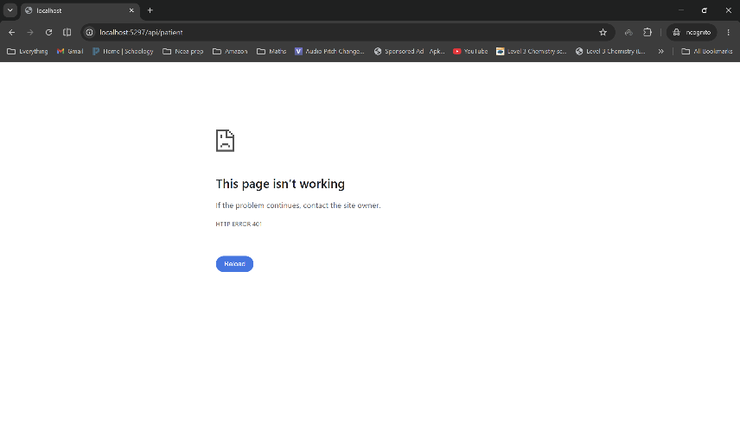
SEC02 | 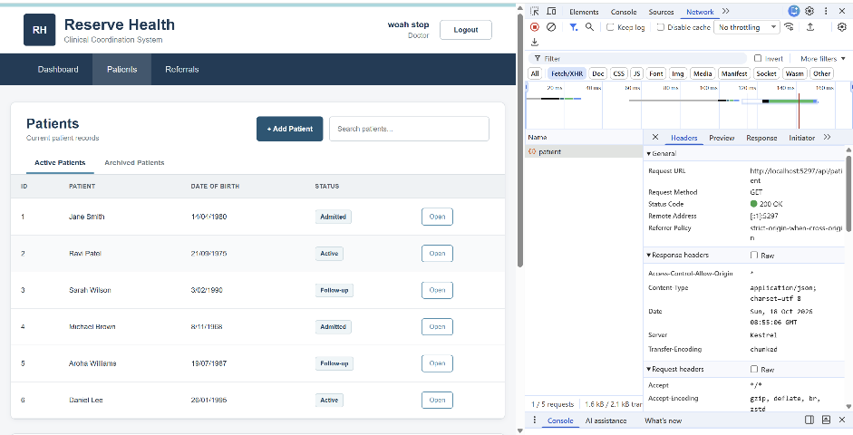
SEC03 | 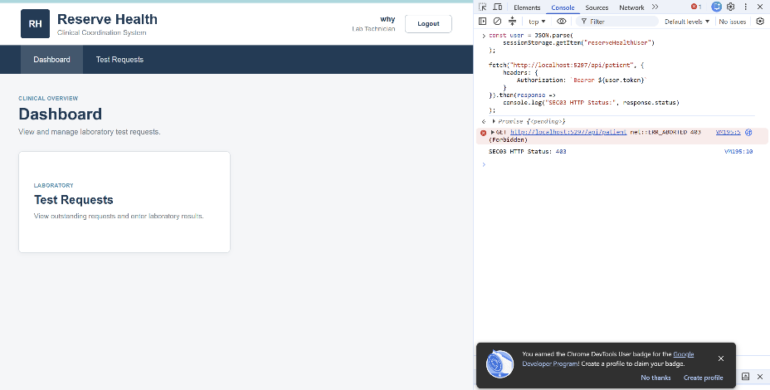
SEC04 | 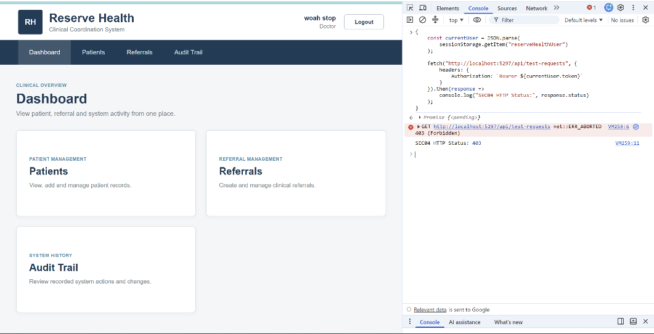
SEC05 | 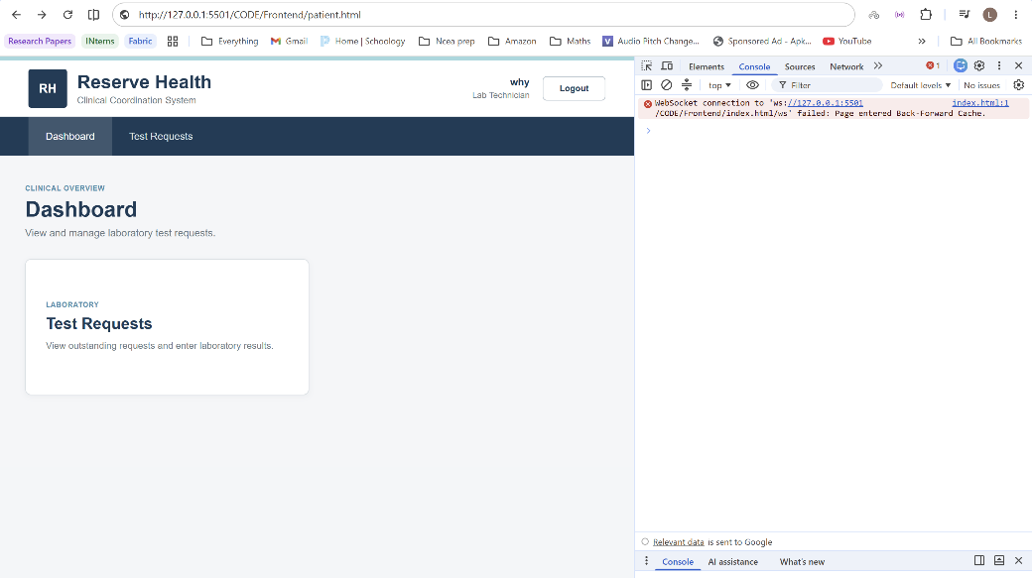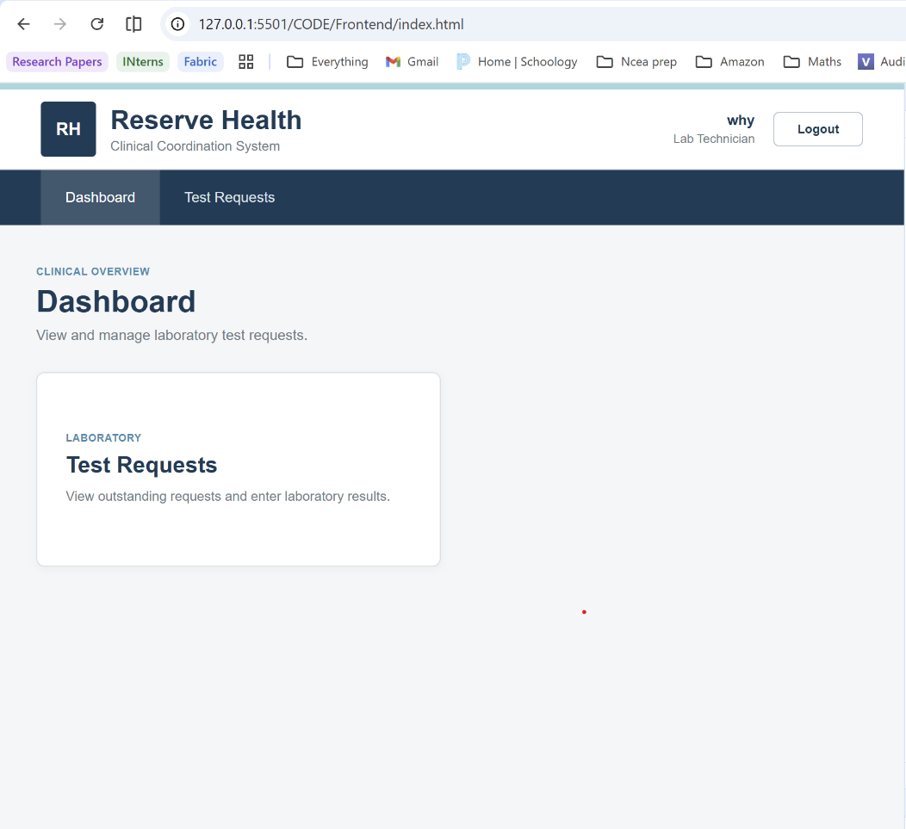
SEC06 | 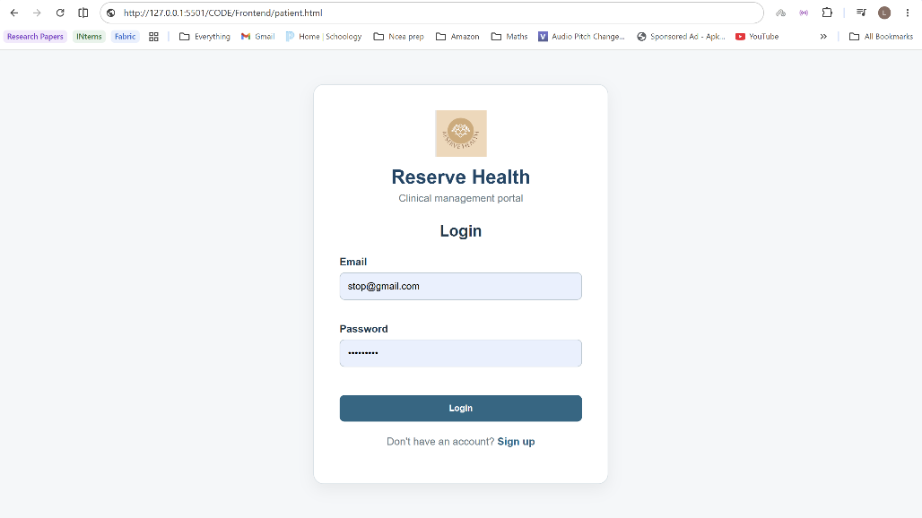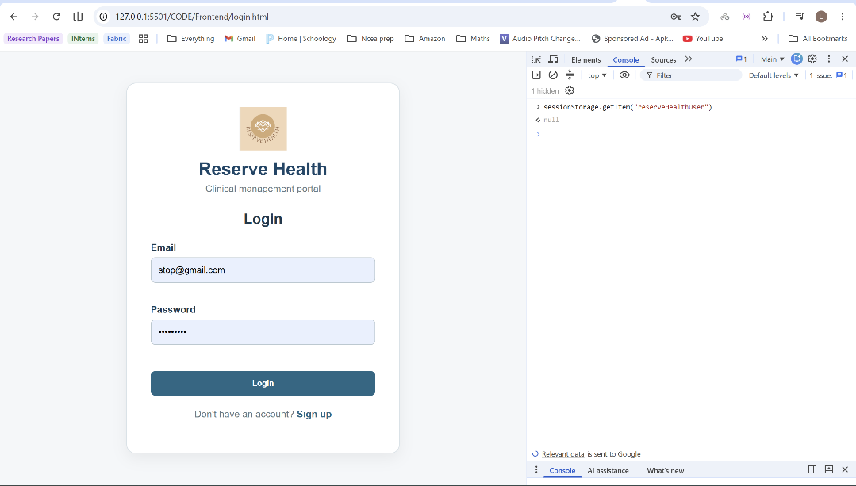
SEC07 | 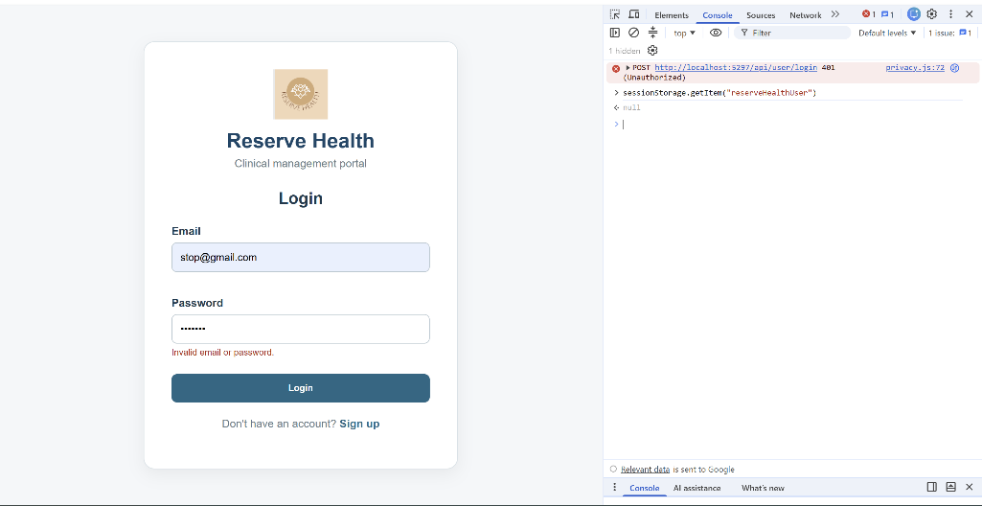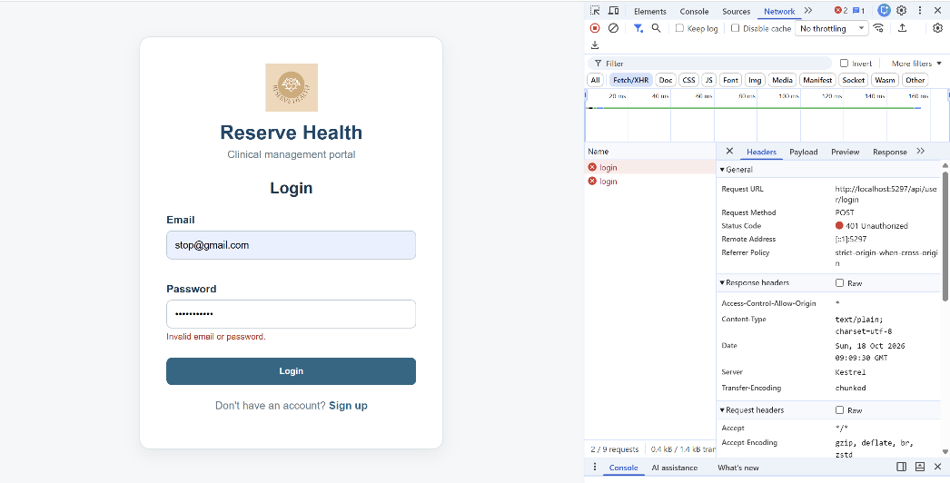

7.3 Accessibility Testing and Evaluation-Hita

7.3.1 Accessibility Testing Approach
Selected accessibility because poor contrast, unclear feedback or missing focus can impede staff completing correct workflows. I combined Desktop Lighthouse with keyboard and form checks on login and Patient pages using the running backend/frontend.
QT-A02 captured the Patient audit before correction and retested it. QT-A03 checked Tab/Shift+Tab order and activation. QT-A04 inspected visible focus. QT-A05 checked labels and incomplete/invalid submissions. These were selected interactions, not every possible state.

7.3.2 Findings and Improvements
The Patient audit improved from 95 to 100 after correcting shared colours. Sravani’s earlier login contrast/main-landmark correction is separate team evidence; her report records 90 to 100. My correction and retest concerned the Patient page.
Selected controls were keyboard reachable and operable, focus was visible, and checked forms provided required/invalid-input feedback. These findings support usability and accessibility within the tested browser, controls and states.
  - Table 12
Test | Expected result and procedure | Actual result and final status | Evidence
QT-A02 | Desktop Patient audit; record finding, fix and repeat | 95 with contrast finding; 100 after correction. Pass on retest | Patient Lighthouse before, contrast details, after
QT-A03 | Tab/Shift+Tab in logical order; activate controls | Selected login/Patient controls reachable and operable. Pass within scope | Manual observation; QT-A04 focus images support selected states
QT-A04 | Focused controls visibly distinguishable | Focus observed on login and Patient controls. Pass within scope | Task7_QT-A04_Login_Focus.png; Patient_Focus.png
QT-A05 | Visible labels and understandable invalid-input feedback | Required/invalid input feedback observed. Pass within scope | QT-A05 login and Patient labels/errors screenshots

Table 11. Accessibility changes and verification scope
Screen / quality issue | Before | After | Evidence and limitation
Patient page – contrast | Lighthouse 95 | Lighthouse 100 | Shared CSS contrast fix, commit 4ce8cd5; existing report Figures 19–21. Desktop audited state only.
Login page – contrast/landmark | Lighthouse 90 | Lighthouse 100 | Team result recorded in Task 8; audit screenshots/commit to confirm before citing as final.
Keyboard/focus/labels | Selected interaction tests | Pass in tested states | QT-A03–QT-A05; not evidence of all keyboard or screen-reader workflows.
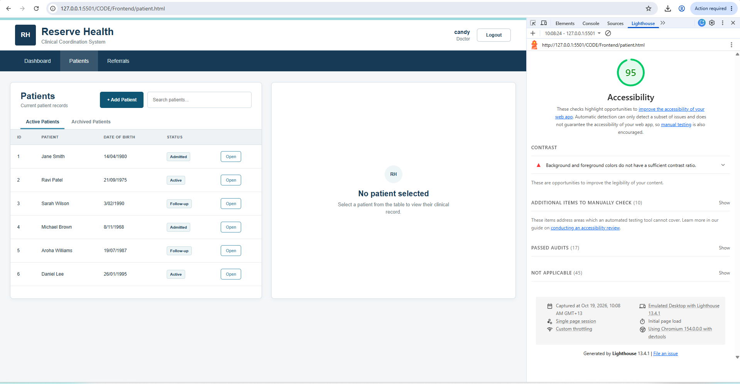Figure 12. QT-A02 Patient Lighthouse before correction, score 95. Hita’s evidence.
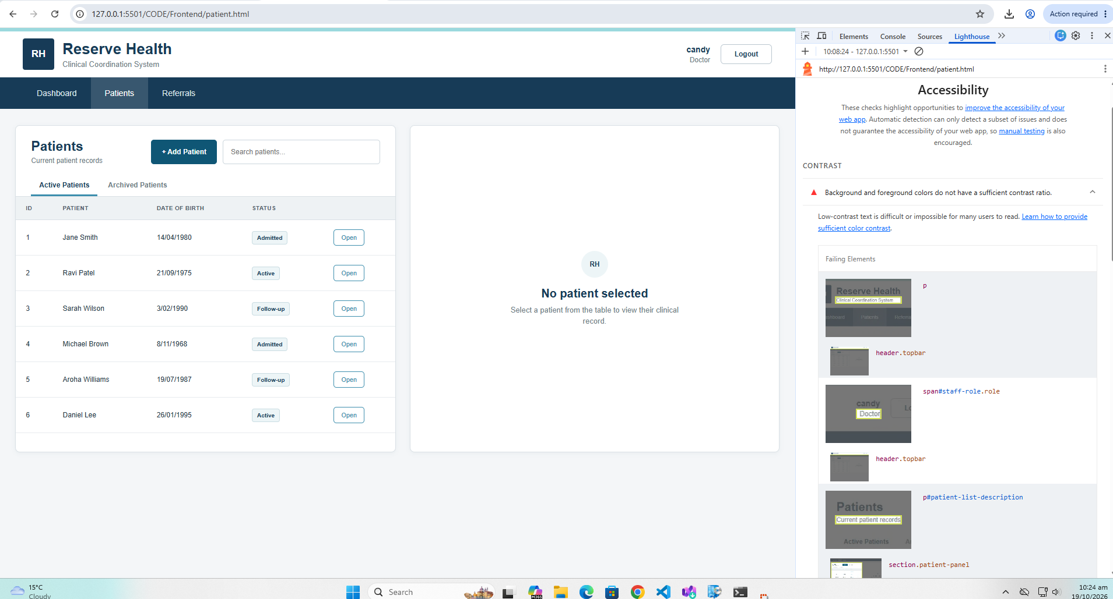Figure 13. QT-A02 insufficient contrast details recorded before correction.
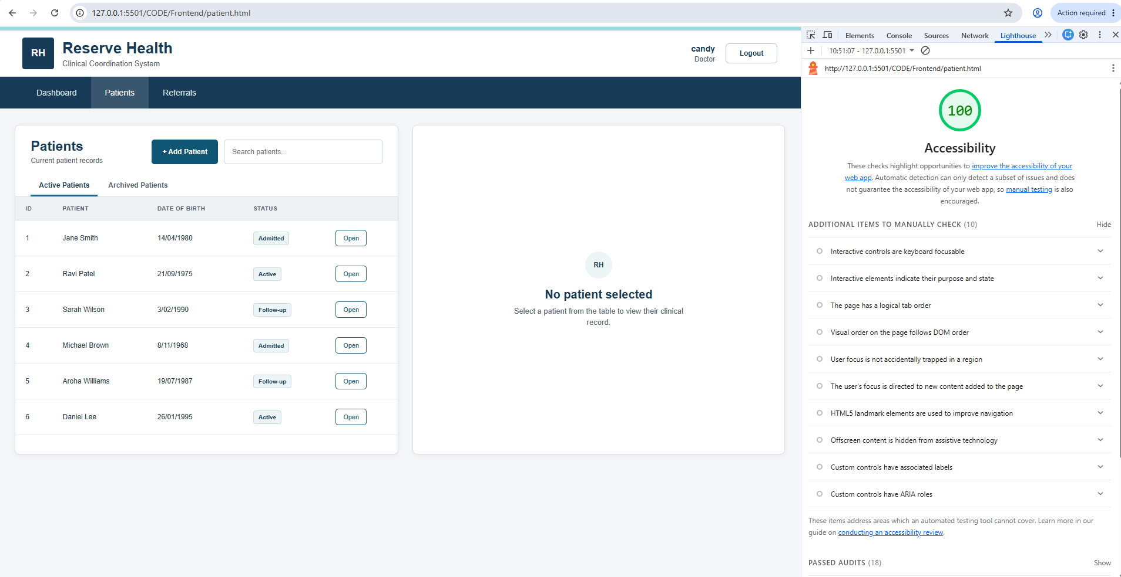Figure 14. QT-A02 Patient Lighthouse retest, score 100 after shared colour correction.

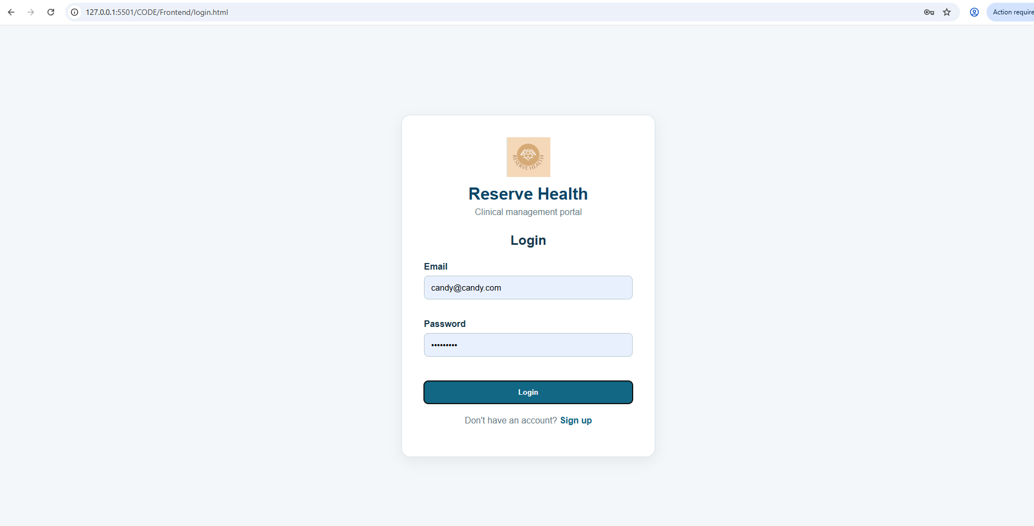Figure 15. QT-A04 visible login focus during keyboard navigation. A screenshot demonstrates a state, not the whole navigation sequence.
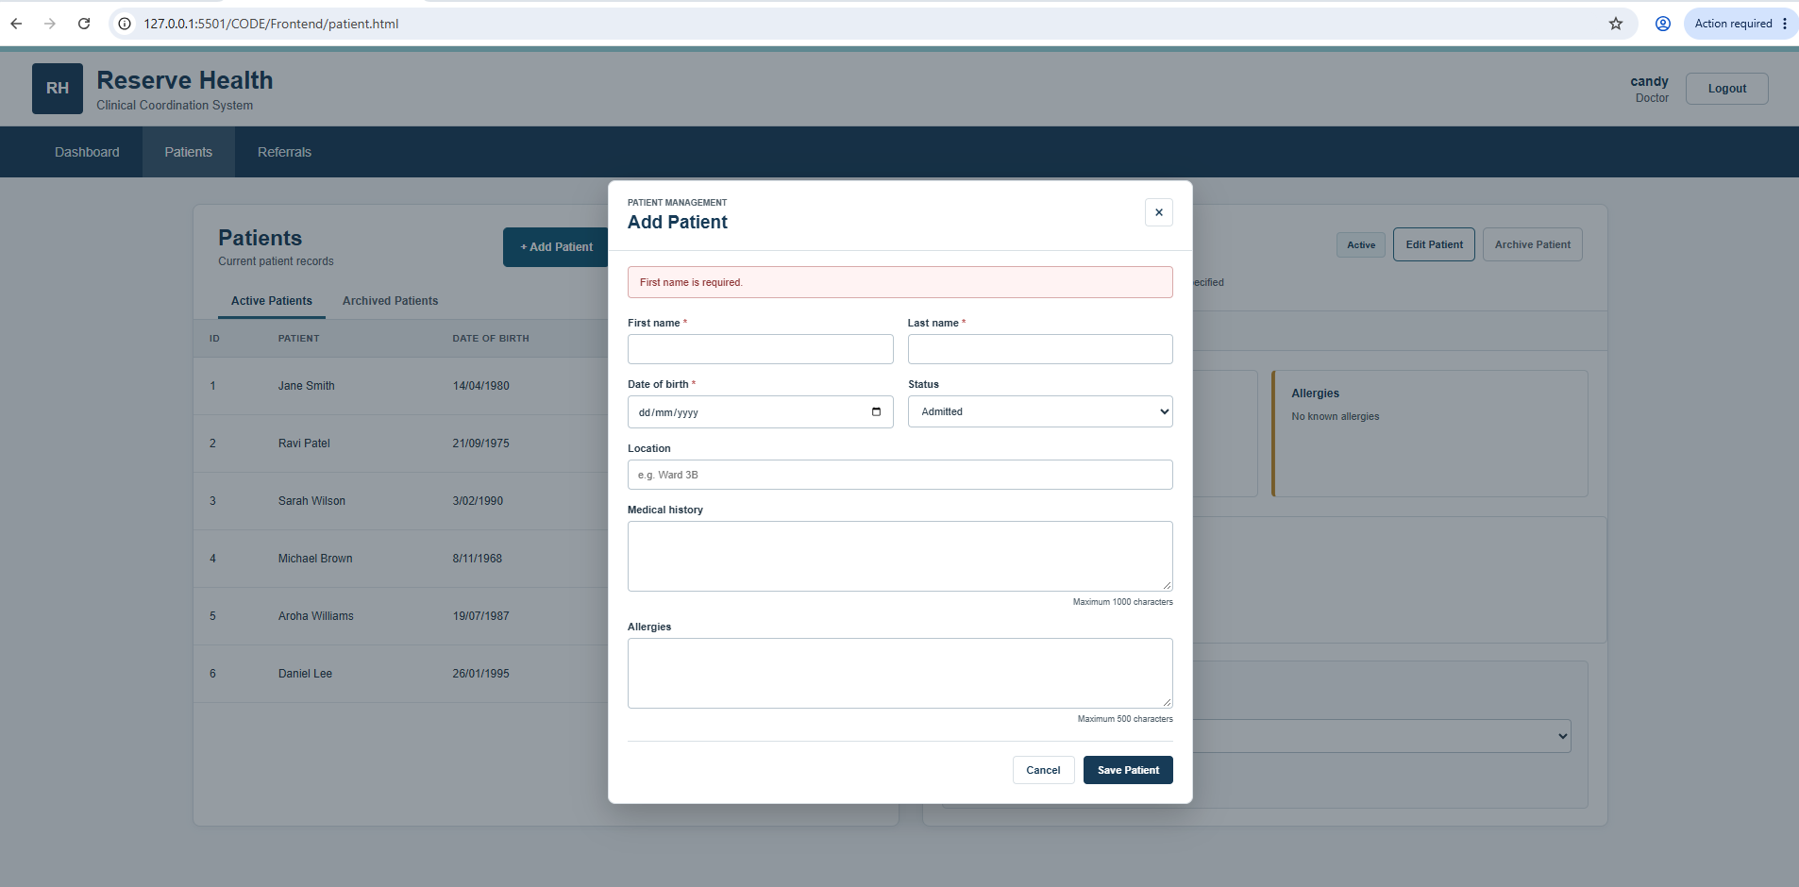Figure 16. QT-A05 Patient form labels and validation feedback in the tested interaction.

7.4 Quality Testing Limitations and Recommended Improvements
Although security testing did provide useful evidence of how the system can handle different security scenarios, there were still limitations to what could be verified from these scenarios. The testing that was carried out was done in a local development environment using a limited amount of accounts and selected API endpoints. This meant that it did not cover all the possible security risks or access combinations. One of the major limitations was the logout functionality. As clearing the user information from sessionStorage prevented access through the normal frontend workflow but did not necessarily invalidate an already issued JWT on the backend. This meant that if the user logged out, the token could potentially remain valid till it expired. Further testing in the future could investigate expired or modified tokens, session expiry and access restrictions across the remaining protected endpoints. This would help identify whether the security controls actually proved to be effective under conditions that extend past being tested manually.
Hitas – accebiltiy
  - Table 13. Security controls, evidence and remaining exposure
Quality control | Evidence in report / ZIP | What remains unverified
Unauthenticated API denial | SEC01 / 401 and patient API automation. | Other API paths and token-manipulation cases.
Doctor and lab authorisation | SEC02–SEC04; nine simulated RBAC automation cases. | All permission combinations; real JWT login for every automated branch.
Direct URL protection | SEC05, selected Lab Technician patient-page access. | All guarded pages and alternative deep links.
Logout/browser session | SEC06 redirect and sessionStorage clearance. | Issued JWT revocation at API; expiry and replay.
Invalid credentials | SEC07 login 401 and UI error; automated login tests. | Rate limiting, lockout policy and broader authentication threats.
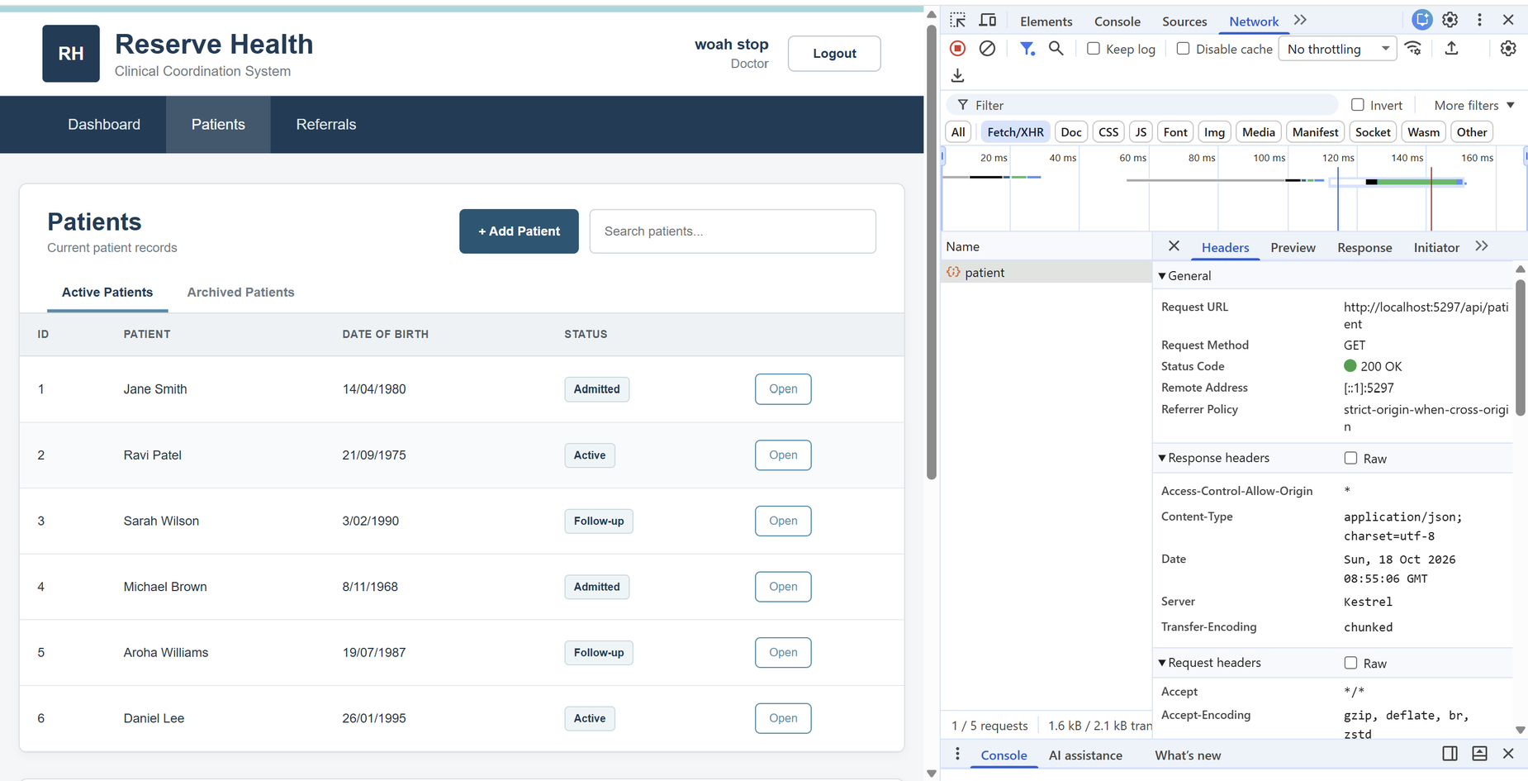
Figure 17. Authorised Doctor access to the Patient API in the selected security scenario.

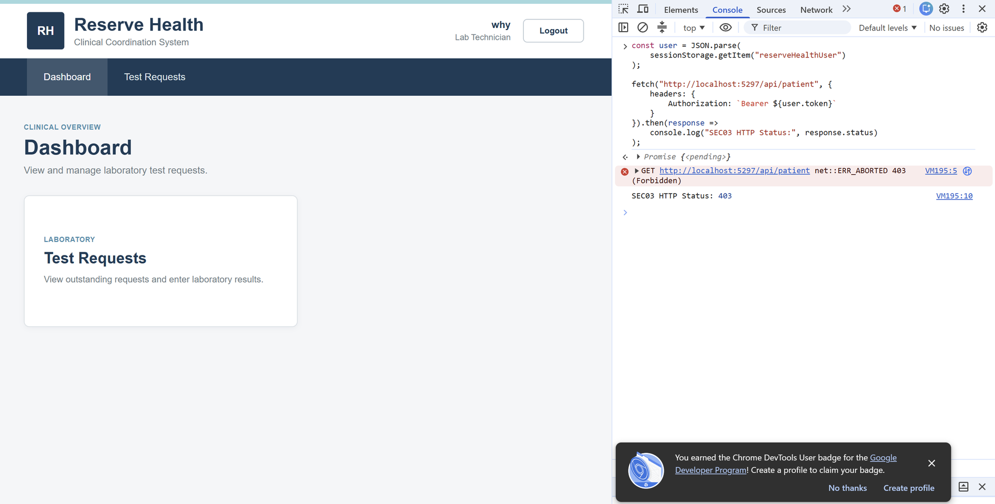
Figure 18. Lab Technician API access rejected for the selected Doctor-only operation.
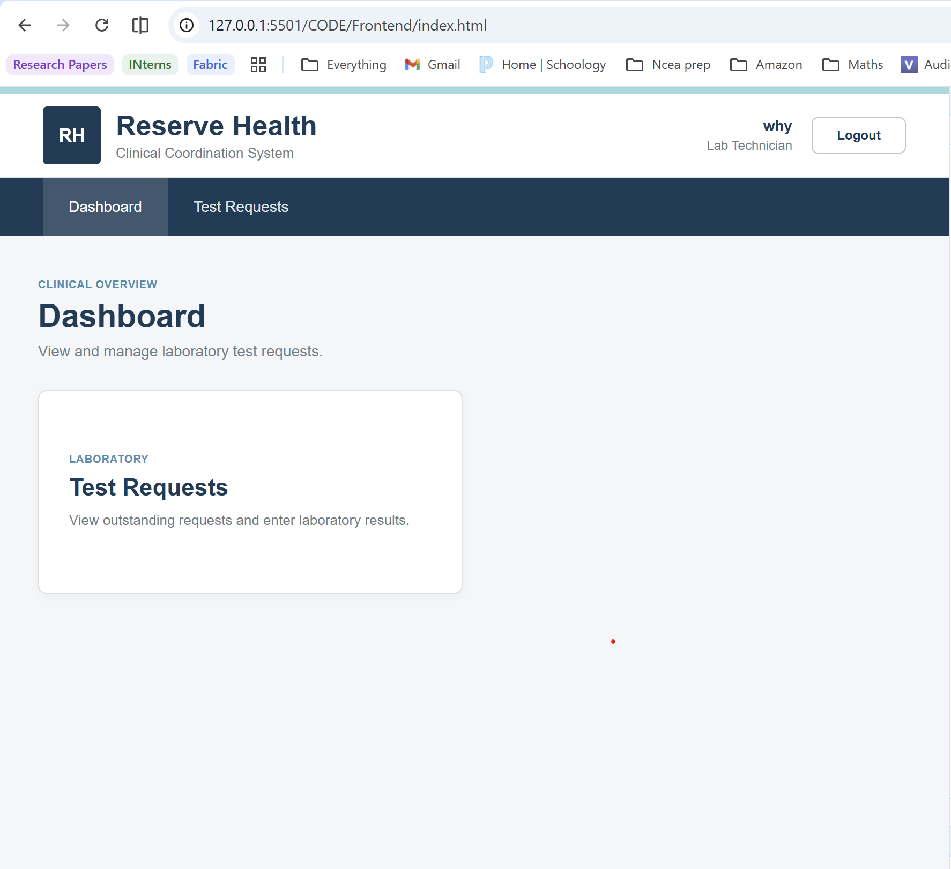
Figure 19. Frontend access restriction observed during the selected direct-URL test.

Task 8: Quality Metrics and Final Release Decision -Sravani

8.1 Final Quality Metrics -Sravani
In terms of final quality metrics, to assess the overall quality of the system we built, we collected measurements from different testing and quality assurance activities that were carried out throughout the project. The measurements allowed us to evaluate the system using recorded results as opposed to using the successful completion of the individual features to decide and investigate the quality of the system. Using the automated and manual security test pass rates, we were able to see the consistency with which the tested scenarios met their expected outcomes, while the CI workflow results showed us whether the system could be built and tested through an automated process. Accessibility scores also helped us to identify measurable improvements that needed to be made to our system, and the issues were then identified and corrected.
The previous sections focused on considering each of these quality measures and techniques as individual measures of quality. So, to determine the quality of the entire system, all the measurements needed to be considered together. For example, a high-test pass rate would not indicate complete requirements coverage, especially if some of the behaviours had not been included in the tests that were executed. To deal with this, we considered requirements verification and defect information to evaluate the final quality of the system. To avoid counting overlapping scenarios more than once and allow the metrics to provide a clear basis for identifying the remaining quality risks and to support our final release decision, we kept different test results separate.

  - Table 14. Final metrics and denominator definitions
Metric (scope) | Calculation / result | Evidence / interpretation
Automated suite pass rate | 21 ÷ 21 = 100% | Final TRX; only the recorded 21 unit/API/integration-style cases.
Test suite execution progress | 21 ÷ 21 = 100% (for discovered final suite) | TRX records 21 total and 21 executed; not progress against all originally planned tests.
Manual security case pass rate | 7 ÷ 7 = 100% (reported) | SEC01–SEC07 test result table and selected evidence.
Local intermediate suite | 16 ÷ 16 = 100% | Test Explorer after setup changes; historical intermediate, not additional final tests.
Patient accessibility improvement | Lighthouse 95 → 100 | QT-A02 before/after from existing report.
Login accessibility improvement | Lighthouse 90 → 100 (reported) | Task 8 statement; audit pair not in supplied ZIP.
Requirements fully verified | Not defensibly calculable | Original baseline / complete RTM criteria and remaining status decisions needed.
Defect closure rate | Not defensibly calculable | D01–D05 plus R01 include setup problems/open risks; category/status denominators need agreement.
CI completion | PR #28 build-and-test green | Actual PR screenshot; distinguish outcome from branch protection enforcement.

8.2 Final Quality Evaluation and Residual Risks -Sravani
In terms of evaluating the final quality of our system, ReserveHealth, we considered how well the implemented system addressed the different quality attributes that were relevant to its intended use. Reliability and data integrity were crucial since patient and referral information needs to always be processed and maintained accurately throughout the different workflows. The validation and integration testing gave us evidence that the tested operations behaved as expected, although the use of an in-memory database for automated integration testing meant that some behaviours specific to the actual SQL Server database were not fully verified through those tests. Another crucial area of quality was security. As mentioned before, the results of our testing proved to us that the system was enforcing access restrictions not only through the frontend but also through the backend. For maintainability, our controllers, models and frontend components were all separated, meaning that they could be updated and tested without necessarily having to change other components or the unrelated functionality of the system. Despite this, we could not fully judge the maintainability from the project structure alone, since the quality of the code, the test coverage and the ease of future modifications would also need to be considered.

Despite the results being positive, we still had to account for the residual risks when we were evaluating the system. One concern was the difference between the automated testing environment and the actual database environment, since passing tests using simulated database behaviour would not guarantee that every operation would work identically with SQL Server. Another limitation that was identified was session management. Removing the stored authentication information during logout did not necessarily invalidate the existing JWT. There were also limitations in the extent of accessibility evaluation, because improvements identified through Lighthouse did not automatically confirm that every page and interaction was accessible. These remaining risks did not necessarily mean that the implemented functionality was incorrect, but they showed that the available testing evidence had boundaries. Therefore, the final evaluation also needed to consider unresolved defects, requirements verification and any outstanding testing before determining whether the system was suitable for release.
  - Table 15. Residual risks and release-gate decision
Residual concern | Why it matters | Needed evidence / condition | Current decision implication
SQL Server differences | InMemory does not model all SQL Server constraints. | Database-specific integration and migrations in a controlled environment. | Outside local prototype assurance.
JWT/session lifecycle | Browser logout does not guarantee token invalidation. | Expiry, revoked/reused token and protected API tests. | Not suitable for production security claim.
Dependencies / warnings | Potential known vulnerable packages or unreviewed warning output. | Triage advisory impact, remediate and rerun CI. | Open wider-release risk.
Incomplete RTM / manual totals | Unknown criteria and pending manual cases weaken coverage claim. | Approved AC, completed manual result log and final RTM. | Only a conditional prototype demonstration decision.
Accessibility breadth | Selected Lighthouse and focus checks omit other users/states. | Screen reader, zoom, responsive, dialogs and wider journeys. | Accessibility remains partially assessed.
Priority alerts / load | P1 boundary and operational-load behaviour not supported by uploaded results. | P1 day 14/15 tests and measured load/profile thresholds. | No readiness claim for time-critical hospital use.

8.3 Final Release Decision -Sravani
In summary, based on the final evaluation, we consider our system to be conditionally ready for release. It can be released in a controlled environment. The quality assurance and testing activities provided evidence that the main implemented workflows were functioning as intended and that the security controls were operating correctly within the scenarios that we evaluated. The successful CI workflow in Task 5 demonstrated to us that the project could be built and tested through an automated process as well if needed. These findings helped us to evaluate whether the system had reached an appropriate level of quality so it could demonstrate its functionality. However, we did not consider the system to be fully ready for an actual healthcare environment, since there were still areas that required further testing and verification before a decision could be taken.
Before we decide to release our system to a wider audience or an actual environment outside of this assignment environment, we would need to consider the final requirements traceability results, outstanding defect status and any other remaining accessibility findings. All of these need to be reviewed to make sure that the unresolved issues would not affect the essential and baseline workflows of our system. To reduce the uncertainty that is associated with our automated integration tests, we would need to apply further testing using the actual database environment. Any of the code changes would need to be tested and reviewed using regression testing and pass the required CI checks again before being considered and included in the release. In terms of the assignment project, we decided it is ready for a conditional release since, in the assignment testing environment, the tests were adequate and successful, as opposed to using these successful results as a reason for real-world production. This decision helped us to demonstrate our prototype while also making sure that the remaining quality risks were addressed before any real-world deployment.

Task 9: AI-Assisted Development and Critical Reflection - Shared

9.1 GitHub Copilot Use and Evidence -Shared
GitHub Copilot was used to investigate potential quality issues in the ReserveHealth system and suggest improvements to existing functionality and testing. The investigation focused on two areas: preventing archived patient records from being modified before restoration and reducing repeated authentication requests caused by clicking the login button multiple times.
The suggestions were reviewed rather than accepted automatically, and follow-up prompts were used when the initial solutions did not behave as expected. This allowed us to evaluate the usefulness of Copilot's suggestions and identify where further testing and human judgement were required.

9.1.1Sravani AI evidence

Investigation One: Archived Patient Integration Testing
Purpose:
The purpose of using GitHub Copilot was to help create an automated integration test to check whether an archived patient could still be edited before being restored. This was important because archived patient records should not be modified accidentally, especially when their information needs to be preserved.
The test was intended to check the behaviour before and after restoring the patient, while also helping us identify whether the existing patient update functionality handled this condition correctly.
Prompt Used:
can you help me add a test to check that an archived patient can't be edited unless they've been restored first
GitHub Copilot Suggestion:
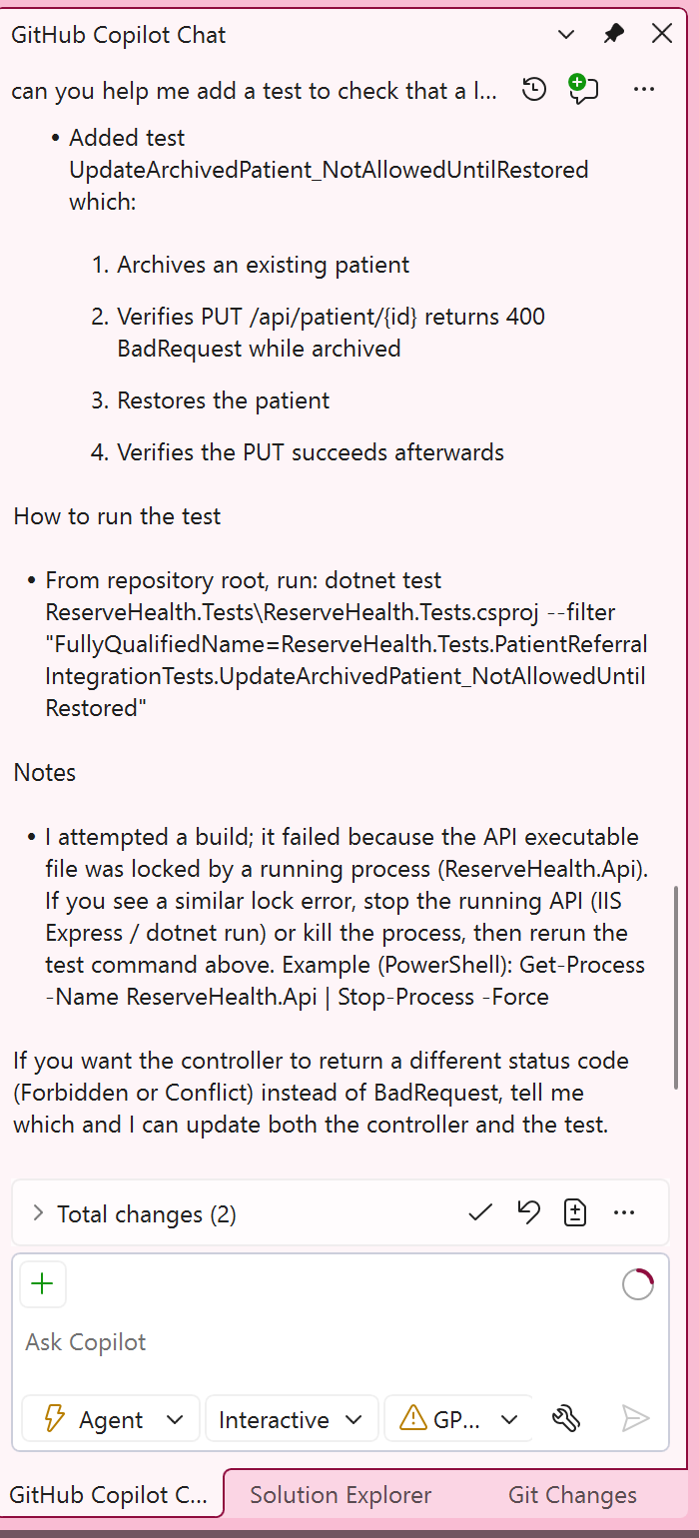

Evidence:
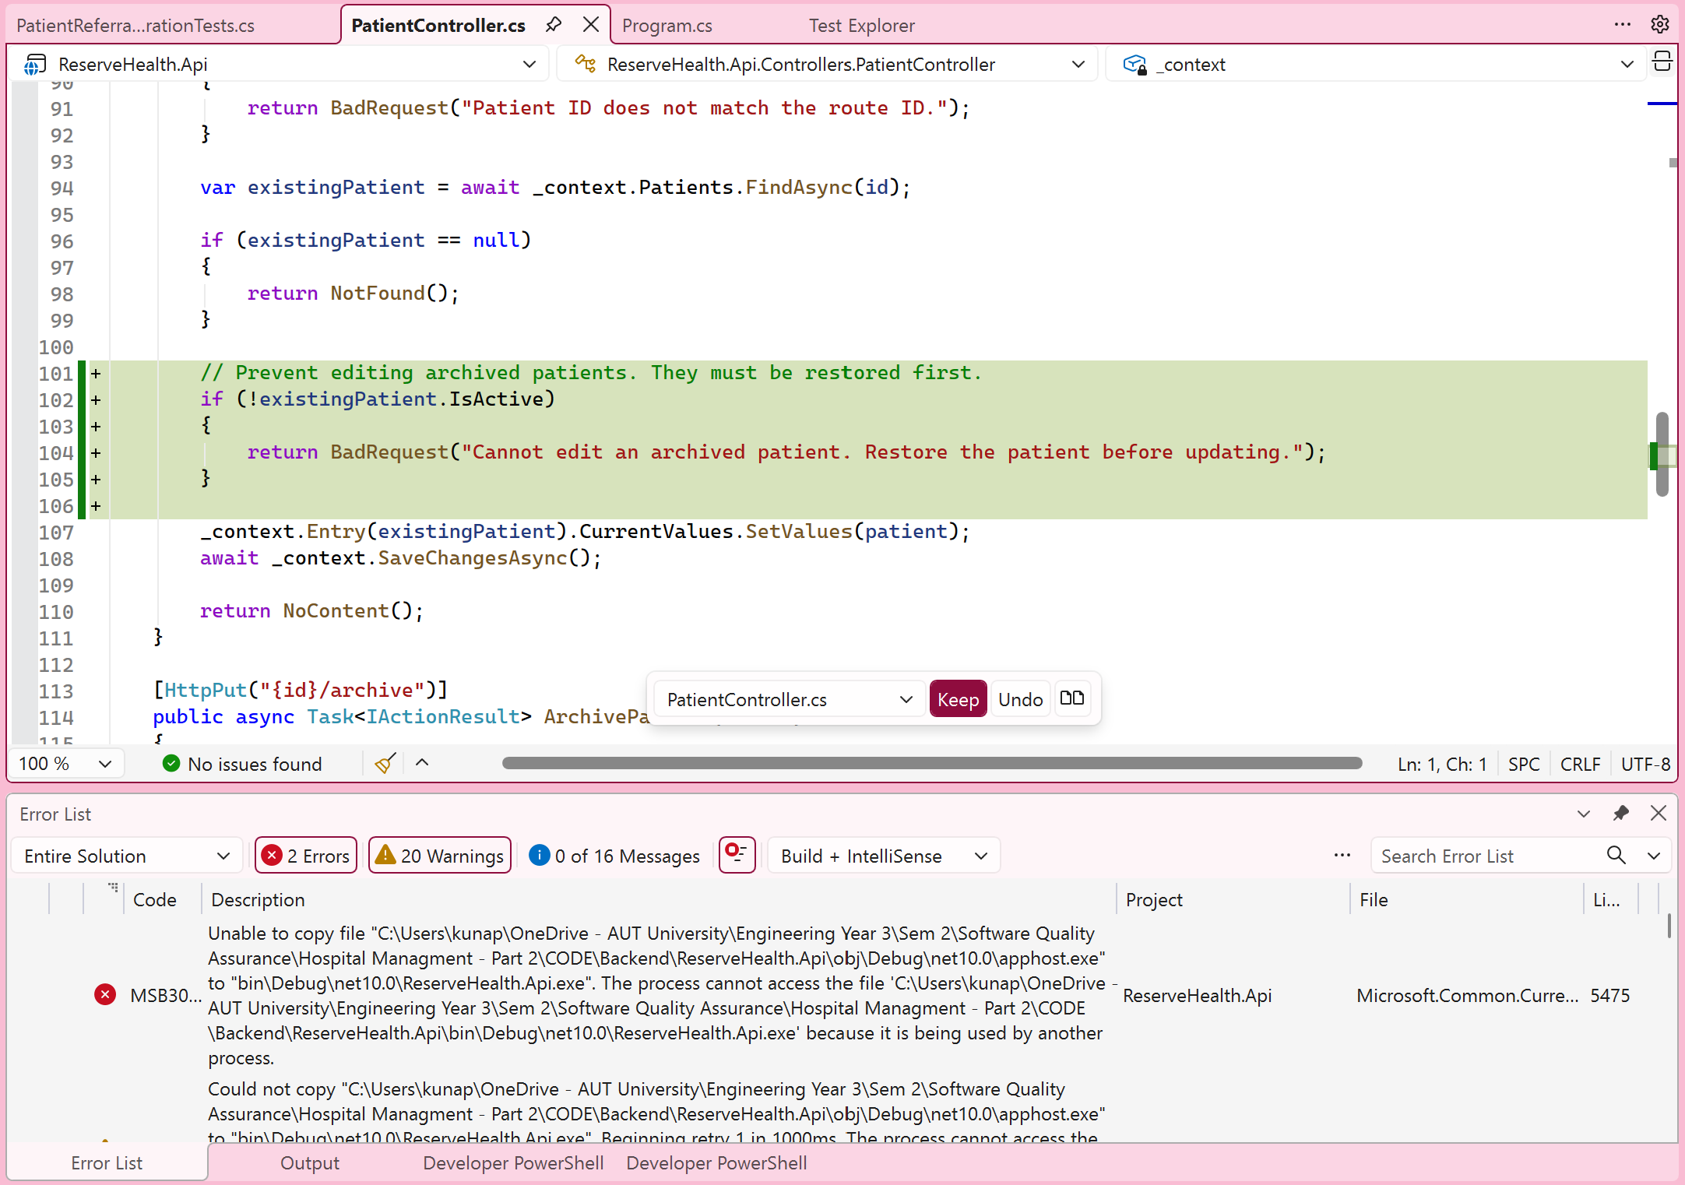
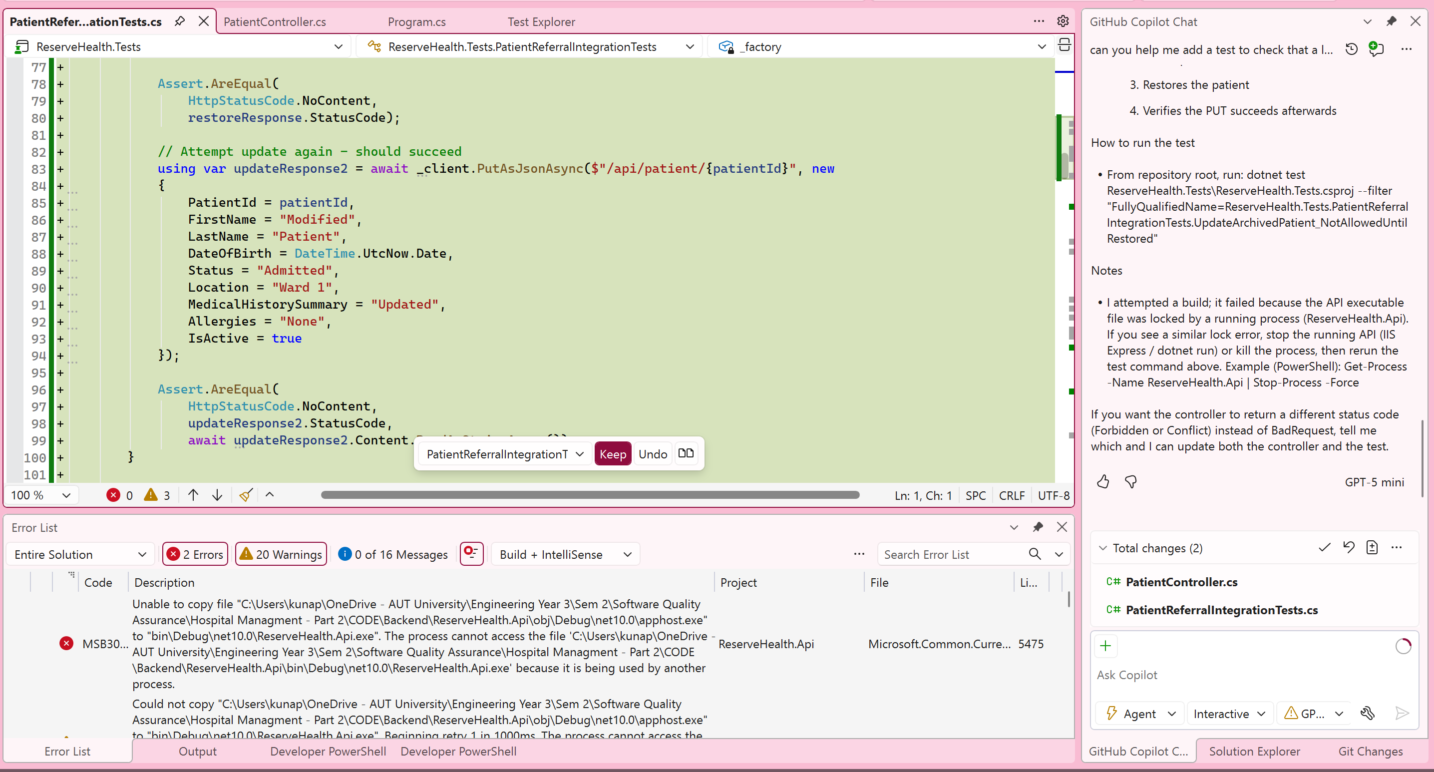
Copilot suggested adding an integration test to PatientReferralIntegrationTests.cs:
[TestMethod]
public async Task UpdateArchivedPatient_NotAllowedUntilRestored()
{
int patientId = await GetExistingPatientId();

// Archive the patient
using var archiveResponse = await _client.PutAsync(
$"/api/patient/{patientId}/archive", null);

Assert.AreEqual(
HttpStatusCode.NoContent,
archiveResponse.StatusCode);

// Attempt to update while archived - should be rejected
using var updateResponse = await _client.PutAsJsonAsync(
$"/api/patient/{patientId}", new
{
PatientId = patientId,
FirstName = "Modified",
LastName = "Patient",
DateOfBirth = DateTime.UtcNow.Date,
Status = "Admitted",
Location = "Ward 1",
MedicalHistorySummary = "Updated",
Allergies = "None",
IsActive = false
});

Assert.AreEqual(
HttpStatusCode.BadRequest,
updateResponse.StatusCode,
await updateResponse.Content.ReadAsStringAsync());

// Restore the patient
using var restoreResponse = await _client.PutAsync(
$"/api/patient/{patientId}/restore", null);

Assert.AreEqual(
HttpStatusCode.NoContent,
restoreResponse.StatusCode);

// Attempt update again - should succeed
using var updateResponse2 = await _client.PutAsJsonAsync(
$"/api/patient/{patientId}", new
{
PatientId = patientId,
FirstName = "Modified",
LastName = "Patient",
DateOfBirth = DateTime.UtcNow.Date,
Status = "Admitted",
Location = "Ward 1",
MedicalHistorySummary = "Updated",
Allergies = "None",
IsActive = true
});

Assert.AreEqual(
HttpStatusCode.NoContent,
updateResponse2.StatusCode,
await updateResponse2.Content.ReadAsStringAsync());
}
Review of the Suggestion
The suggested integration test follows the patient archive and restore workflow in three stages. It first archives an existing patient and checks for an HTTP 204 response. It then attempts to update the archived record, expecting an HTTP 400 Bad Request response. Finally, it restores the patient and attempts the update again, expecting HTTP 204 No Content.
The suggestion was useful because it provided a way to test the relationship between the archive, update and restore operations rather than checking each function separately. However, the expected response codes and behaviour still needed to be checked against the existing requirements and implementation. The build problem encountered during this investigation also prevented the suggestion from being fully verified, so a successful test outcome could not be confirmed.

Investigation Two: Preventing Repeated Login Requests
Purpose:
The purpose of using GitHub Copilot was to improve the login functionality by preventing multiple requests from being sent when the Login button was clicked repeatedly.
This was considered important because repeated submissions could result in unnecessary requests being sent to the backend, especially when users were experiencing delays or were unsure whether their login attempt had been processed.
Copilot was used to suggest changes to the existing JavaScript functionality without needing to redesign the login interface.
Initial Prompt:
can you make it so the login button doesn't send multiple requests if i click it more than once
Initial Copilot Suggestion:
GitHub Copilot suggested updating the login form to prevent multiple requests when the user clicked the login button repeatedly.
File identified: CODE/Frontend/privacy.js
The proposed changes included:
- Adding a form-level submitting flag using loginForm.dataset.submitting to ignore additional submissions.
- Disabling the submit button when a login request was sent.
- Re-enabling the button and clearing the flag inside a finally block so the form would reset after an error or successful completion.
Evidence :
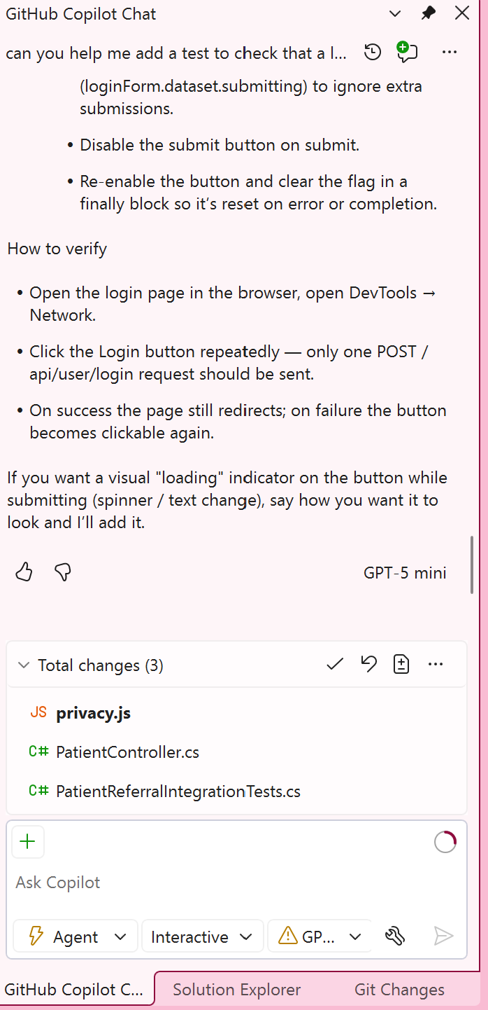
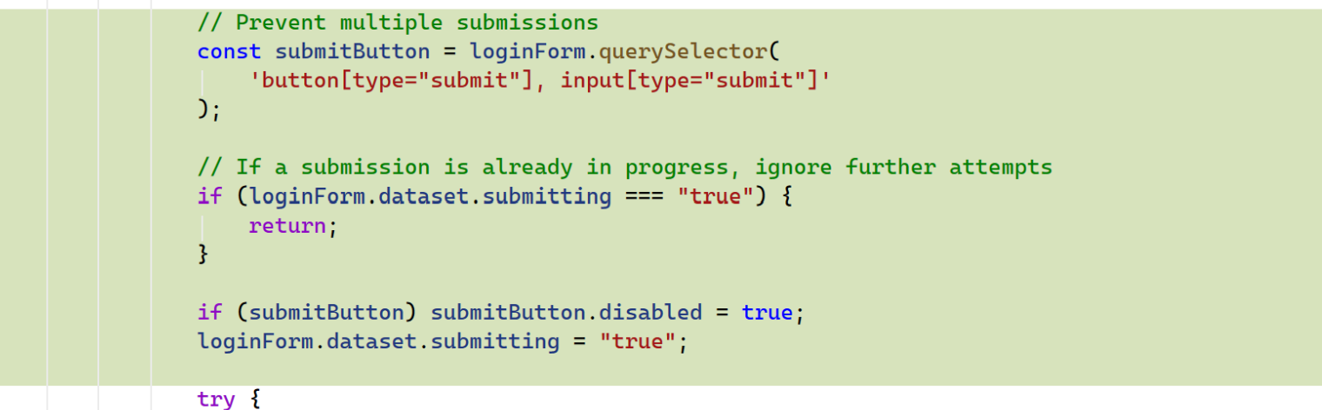
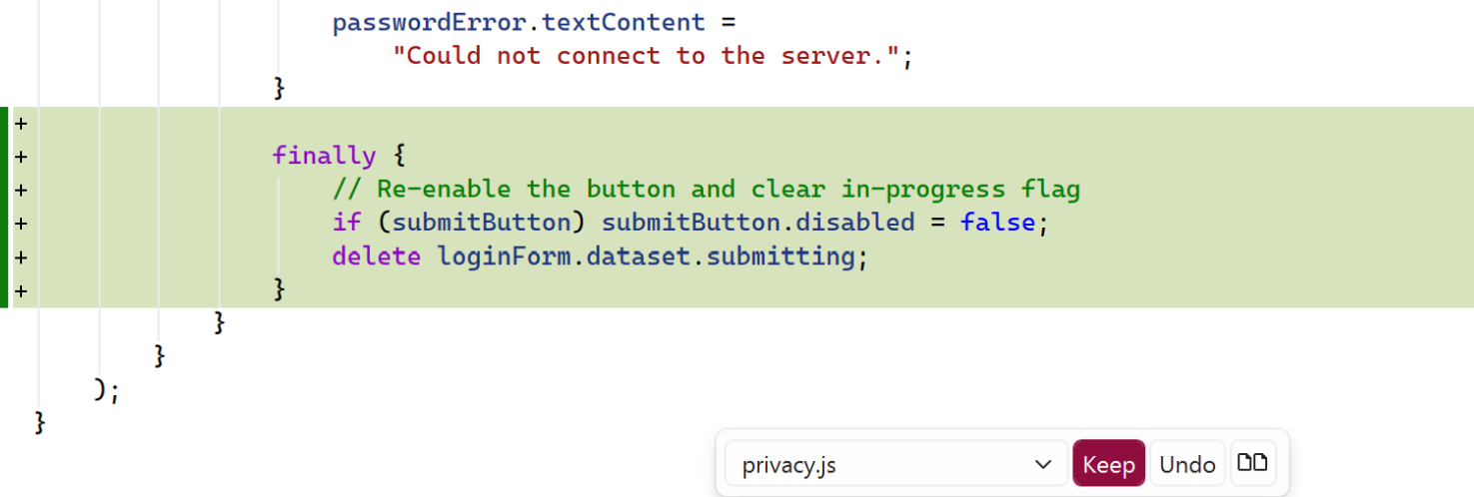
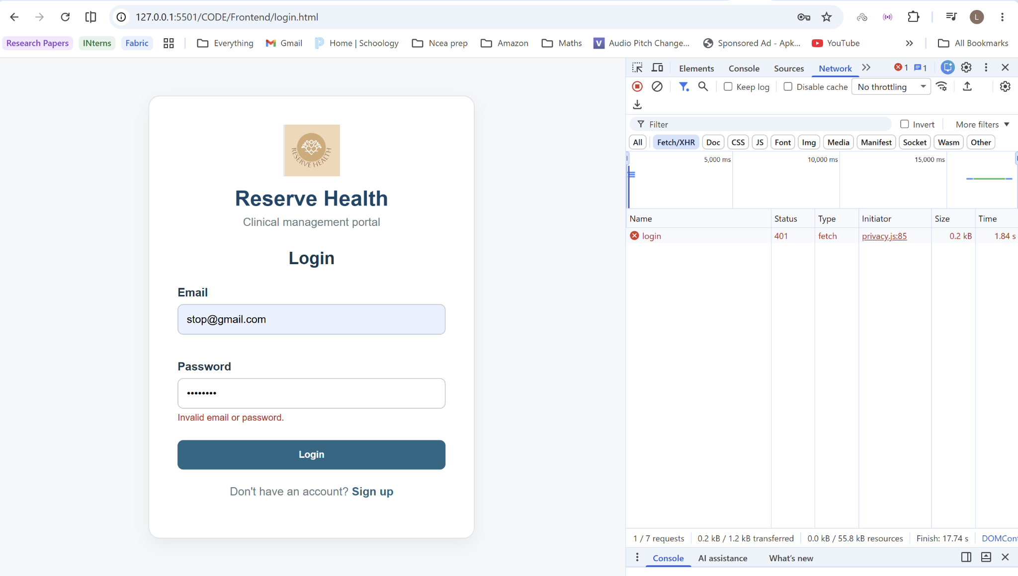
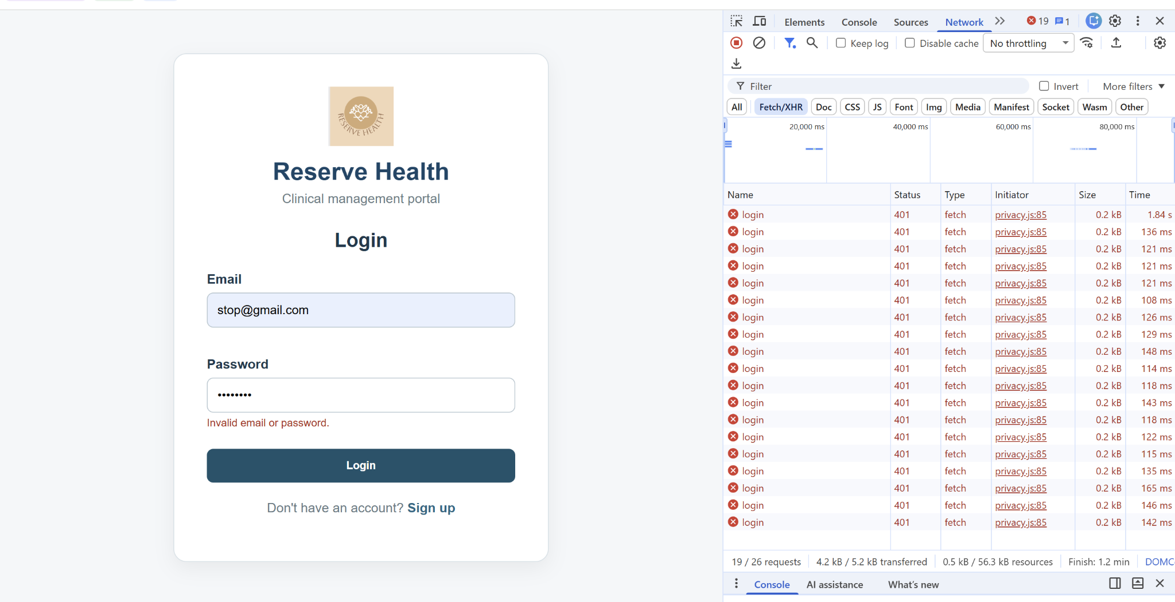
Copilot also suggested the following verification procedure:
- Open the login page in a browser.
- Open Developer Tools and navigate to the Network tab.
- Click the Login button repeatedly.
- Check that only one POST /api/user/login request is submitted while the previous request is being processed.
- Check that successful login still redirects correctly and that the button becomes available again after a failed attempt.
Copilot additionally offered to add a visual loading indicator, such as a spinner or button text change, although this was not part of the original request.

Testing and Evaluation of the Initial Suggestion
After testing the initial Copilot suggestion, we found that the login button could still send multiple requests when clicked repeatedly. Although the suggested changes prevented submissions while a request was being processed, the button became available again almost immediately because the API responded quickly.
Browser Network testing showed that repeated clicks could still generate multiple authentication requests. This meant that the proposed submission flag was not sufficient to prevent repeated attempts when the server returned a response quickly.
The initial suggestion was therefore only partially effective, and a follow-up prompt was needed to investigate another approach.

First Follow-Up: Introducing a Two-Second Cooldown
Purpose:
After testing the initial Copilot suggestion, we found that the login button could still send multiple requests when clicked repeatedly. Although the suggested changes prevented submissions while a request was being processed, the button became available again almost immediately because the API responded quickly.
The purpose of the follow-up prompt was to address this limitation by keeping the button disabled for a short period after each attempt. This allowed us to investigate whether introducing a delay would reduce repeated requests and improve how the login form handled user interactions.

Follow-Up Prompt
it still sends loads of login requests when i click quickly. can you make the button wait 2 seconds before i can try again, even if the request finishes straight away

Proposed Improvement and Evaluation
The requested improvement was to introduce a two-second cooldown that would apply even when the previous authentication request had already finished.
This differed from the original submission flag, which only prevented additional submissions while a request was still being processed.
Further browser testing showed that the delay reduced the frequency of repeated requests but did not fully prevent another submission using the same login credentials. The button could still become available again once the cooldown expired, even if the user had not corrected the information entered.
The cooldown therefore provided a partial improvement, but additional changes were considered necessary to address repeated unsuccessful login attempts.

Evidence:
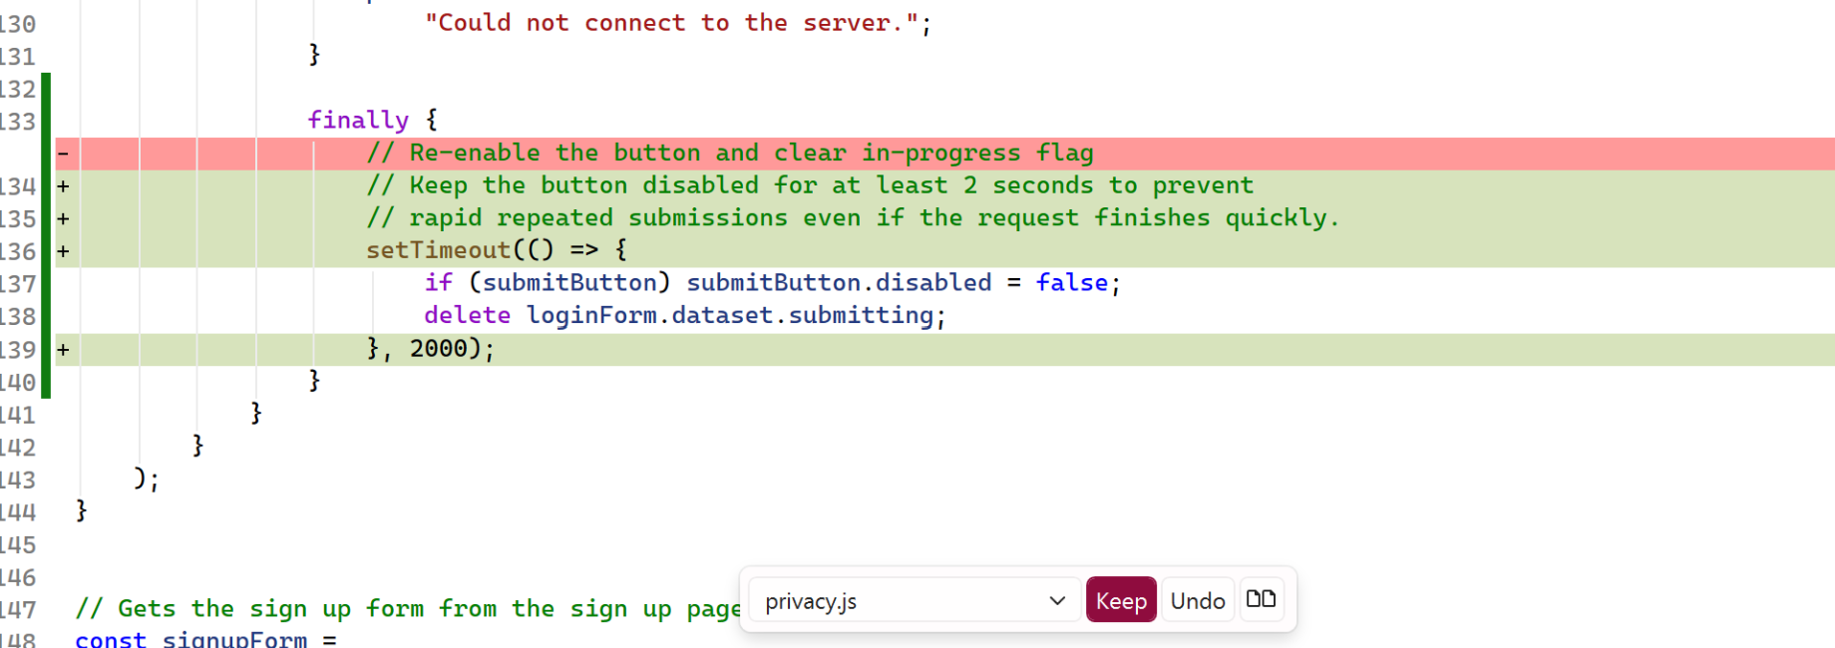
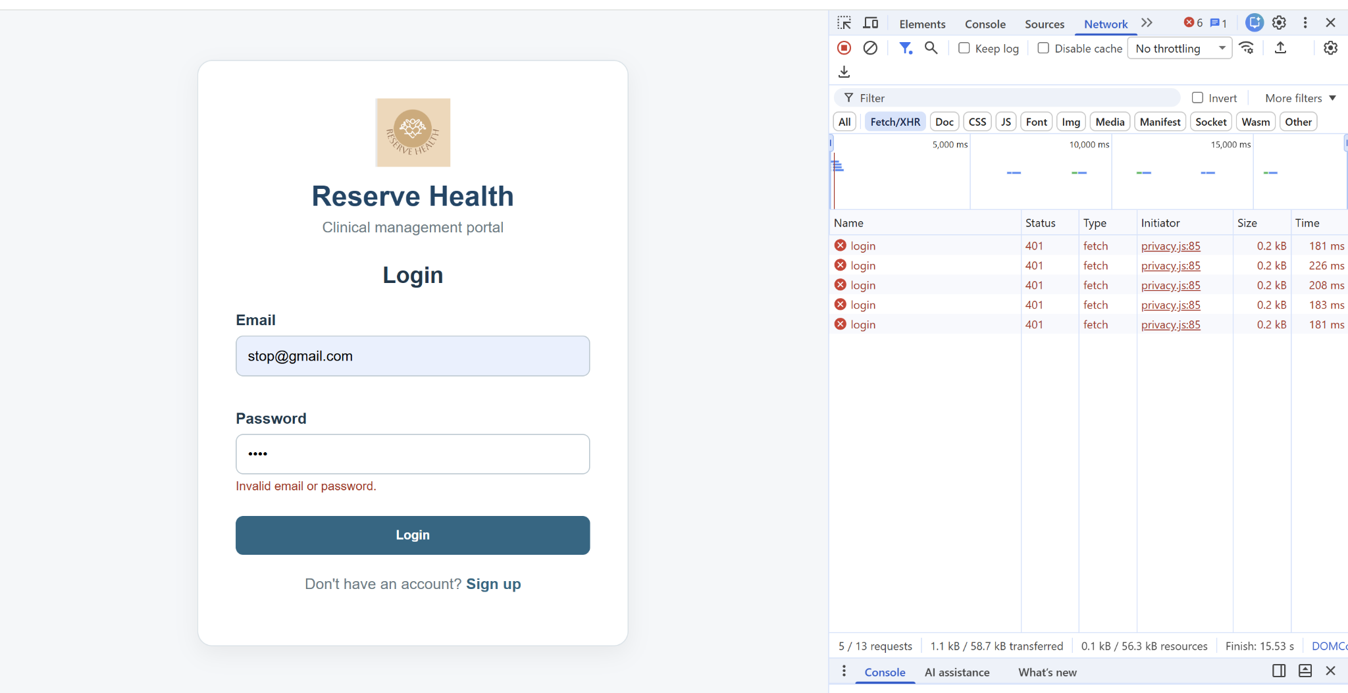
  - Five unsuccessful login requests during cooldown testing

Second Follow-Up: Disabling Login Until Credentials Change
Purpose:
The purpose of the second follow-up prompt was to improve the previous solution after further testing showed that the two-second delay only reduced how frequently requests could be sent rather than preventing repeated attempts using the same information.
We wanted the login button to remain disabled after an incorrect password until the user changed their email or password.
This approach was intended to prevent unnecessary repeated submissions while still allowing users to correct their credentials and attempt to log in again. It also gave us another opportunity to evaluate how Copilot responded to problems identified during testing.
Follow-Up Prompt:
can you make the login button stay disabled after a wrong password until i change the email or password instead of just waiting 2 seconds
GitHub Copilot Suggestion
Copilot responded that it had updated the login page behaviour so that after an incorrect password, the submit button would remain disabled until the user modified the email or password, while preserving the two-second cooldown for other outcomes.
File identified: CODE/Frontend/privacy.js
The suggested changes included:
- Adding input listeners to the email and password fields.
- Clearing an invalid-credentials lock when the user edited either field.
- Using loginForm.dataset.invalid = "true" to record an invalid-login state.
- Keeping the submit button disabled after an invalid-login response until the user changed their credentials.
- Preserving the existing two-second cooldown for network errors or other failure conditions.
Copilot described the intended behaviour as follows:
Incorrect credentials: The button remains disabled until the user changes the email or password, preventing another attempt with unchanged credentials.
Network error or other failure: The button remains disabled for two seconds before becoming available again.
Successful login: The existing redirect behaviour continues.
Copilot also suggested that a visual indicator could be added, such as changing the button text to "Locked" or showing an explanatory message while the form remained disabled.

Evidence:
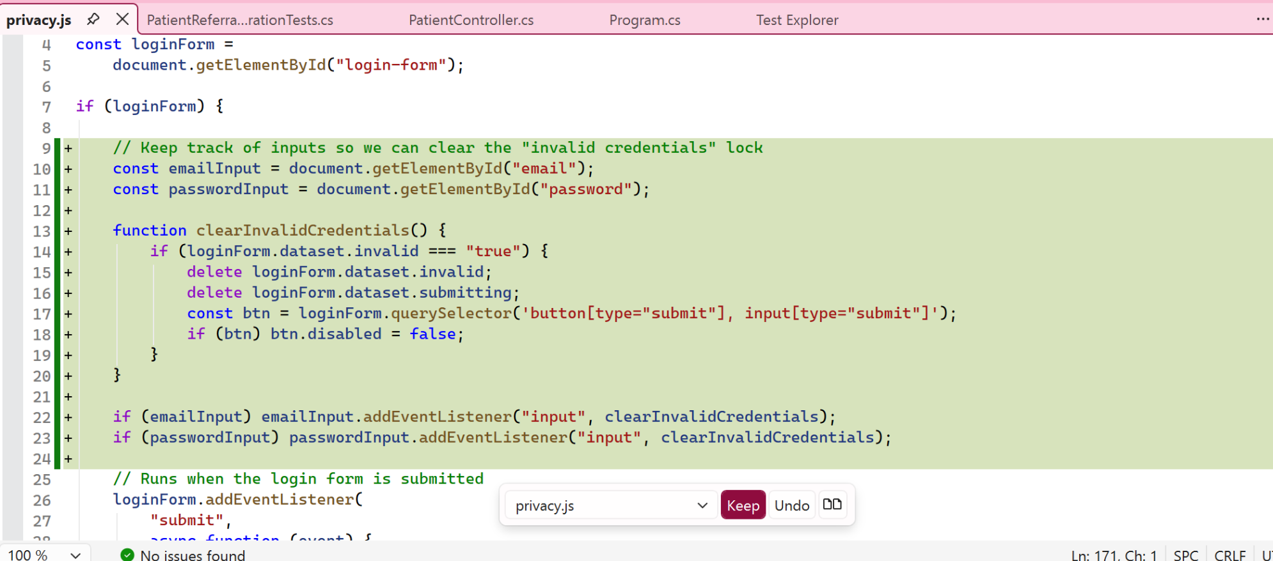
Review and Final Decision
The final suggestion addressed a limitation of the previous cooldown approach by linking the availability of the login button to changes in the user's credentials.
However, the proposed functionality also changed how users could interact with the login form after an unsuccessful attempt. This required consideration of whether the additional restriction was appropriate for the intended login workflow and whether it introduced unnecessary complexity.
The changes proposed during the login investigation were ultimately not retained, and privacy.js was returned to its implementation from before the Copilot experiment.
Rather than keeping a modification simply because Copilot had generated it, the decision was made to preserve the existing functionality when the proposed changes could not be sufficiently justified and verified.

9.1.2 Hita AI Evidence

9.2 Human Review, Modification and Testing -Shared
The investigation showed that GitHub Copilot was useful for generating initial test ideas and suggesting modifications to existing code. The archived-patient integration test provided a possible way to verify the archive and restore workflow, while the login investigation allowed several approaches to preventing repeated requests to be explored.
However, the suggestions still required review and testing. The initial login modification appeared to prevent repeated requests, but further testing showed that the button could become available again almost immediately. The two-second cooldown reduced the frequency of requests, although it did not prevent repeated attempts indefinitely. The subsequent credential-change approach introduced a further restriction that needed to be evaluated against the intended login behaviour.
The investigation also showed the importance of distinguishing between proposed functionality and verified results. Copilot could suggest code and describe how it should work, but those explanations were not sufficient evidence that the changes worked correctly in the application.

Overall, GitHub Copilot supported the investigation process, but human judgement was still required to identify limitations, formulate follow-up prompts, evaluate the effects on existing functionality and decide whether the changes should be retained. In this case, the login modifications were rejected rather than introducing behaviour that had not been adequately verified.

Task 10: Quality Improvement and Future Recommendations -Hita

10.1 Quality Lessons and Process Improvements - Hita
The project taught me that a working interface, passing suite and accessibility score answer different questions. Missing lab data blocked testing, while a functional Patient page still had contrast problems. Each quality claim needs appropriate evidence and boundaries.
Test preparation needs documented SDK, database, migrations, accounts and records. Recording the initial fixture blockage explained the later execution. A clean-machine checklist would reduce repeated setup diagnosis.
Combining main before rerunning tests and using PR checks improved integration confidence. Maintaining the RTM, defect register and test log during development would avoid reconstructing their relationships during final reporting.

10.2 Future Quality Improvements Hita
Before wider release, prioritise vulnerable-dependency review and authentication/session checks, including expiry, logout and other protected endpoints. Changes need targeted regression and CI. Passing selected role tests does not settle unrelated security risks.
Add isolated SQL Server integration checks for migrations and persistence alongside fast in-memory tests. Manage lab fixtures with explicit reset instructions. Extend audit/history tests to attribution, ordering and multiple records.
Extend accessibility with screen readers, dialog focus, zoom and responsive checks. Performance, monitoring and recovery remain future work. Use Goal–Question–Metric to define each improvement’s evidence and acceptance threshold.

Task 11: Team Contribution and Professional Reflection -Shared

11.1 Team Contribution Statement -Shared

11.2 Individual Professional Reflection -Shared

Conclusion - hita

